# AlmaNEO (ALMAN) Whitepaper v3.0

**"Democratizing Intelligence, Cultivating Humanity"**

─────────────────────────────────────────────────────────────────

## 1. Abstract

### A New Evolutionary Leap for Humanity

Artificial intelligence is the most powerful tool in human history. However, this tool is currently concentrated in the hands of a few.

Over 90% of the world's AI computing resources are monopolized by the top 1% of companies and countries. A $20 monthly subscription fee might cost a few cups of coffee for a young person in developed countries, but it represents a significant portion of a young person's monthly living expenses in the Global South. The moment intelligence becomes monetized, the ladder of opportunity collapses.

**AlmaNEO (ALMAN)** is the answer to this problem.

We are redeploying the AI infrastructure monopolized by large capitalists as a public good for all of humanity. AlmaNEO is a token for the world's 8 billion people and a **"lifeboat of intelligence"** that guarantees free AI access to marginalized young people.

But we don't stop at simply distributing technology.

As AI becomes more sophisticated, human warmth becomes increasingly valuable. AlmaNEO, inspired by Korea's culture of "jeong" (情), is building a new economic system that values acts of helping others and showing solidarity. A world where kindness becomes an asset—that's the future AlmaNEO envisions.



─────────────────────────────────────────────────────────────────

### Core Components

|  |  |
| --- | --- |
| **Component** | **Description** |
| GAII | Global AI Inequality Index - A transparent index that measures AI inequality in real time |
| AlmaNEO AI Hub | Free AI services provided through DePIN-based distributed computing |
| Kindness Protocol | Proof of Humanity, which verifies and rewards kindness and solidarity |

─────────────────────────────────────────────────────────────────

### Our Promise

* 8,000,000,000 ALMAN — One token for one person, 8 billion people worldwide
* Zero Barrier — No wallet, no gas fees, anyone can get started in 5 seconds
* Kindness is Value — A fair ecosystem where kind people have more opportunities

─────────────────────────────────────────────────────────────────

### Vision

|  |
| --- |
| *"Cold Code, Warm Soul" By adding a warm soul to cold code, we create a world where technology does not alienate humans, but rather perfects them.* |

AlmaNEO goes beyond currency and will become the **identity card** of "kind friends" who have not lost their humanity in the AI era.

─────────────────────────────────────────────────────────────────

*This document details the vision, technical architecture, and token economy of the AlmaNEO project.*

## 2. Problem Statement: Invisible Barriers

### In the AI Era, Who Owns Intelligence?

In 2024, humanity has acquired the most powerful tool in history. AI writes, codes, diagnoses medical conditions, and interprets laws. The gap between those who have these tools and those who do not is faster and deeper than any previous technological revolution.

But one question remains:

|  |
| --- |
| *"Who owns this powerful intelligence?"* |

─────────────────────────────────────────────────────────────────

### 2.1 AI Inequality: A New Form of Colonialism

Just as the previous industrial revolution brought about inequality in physical labor, the AI revolution is creating **inequality in 'thinking and intelligence'**.

**Real-World Numbers:**

|  |  |
| --- | --- |
| **Indicators** | **Current Status** |
| AI Computational Resource Concentration | The Top 1% of Companies Own Over 90% of Global GPUs |
| AI Service Costs | $20 per month (Youth in developed countries: 4 cups of coffee / Youth in the Global South: 10-30% of monthly living expenses) |
| AI startup investment | The US and China account for over 80% of global investment |
| Language bias | More than 90% of the training data for major AI models is in English |

Universities in developed countries use AI to complete assignments, learn coding, and test startup ideas. At the same time, college students in developing countries are labeling the data needed to build that AI for a few dollars an hour.

**This is the true face of 21st-century digital colonialism.**

─────────────────────────────────────────────────────────────────

### 2.2 Monetization of Intelligence: The Collapsing Ladder of Opportunity

Education was a ladder of social mobility. Society was sustained by the belief that even children from poor families could achieve a better life if they studied hard.

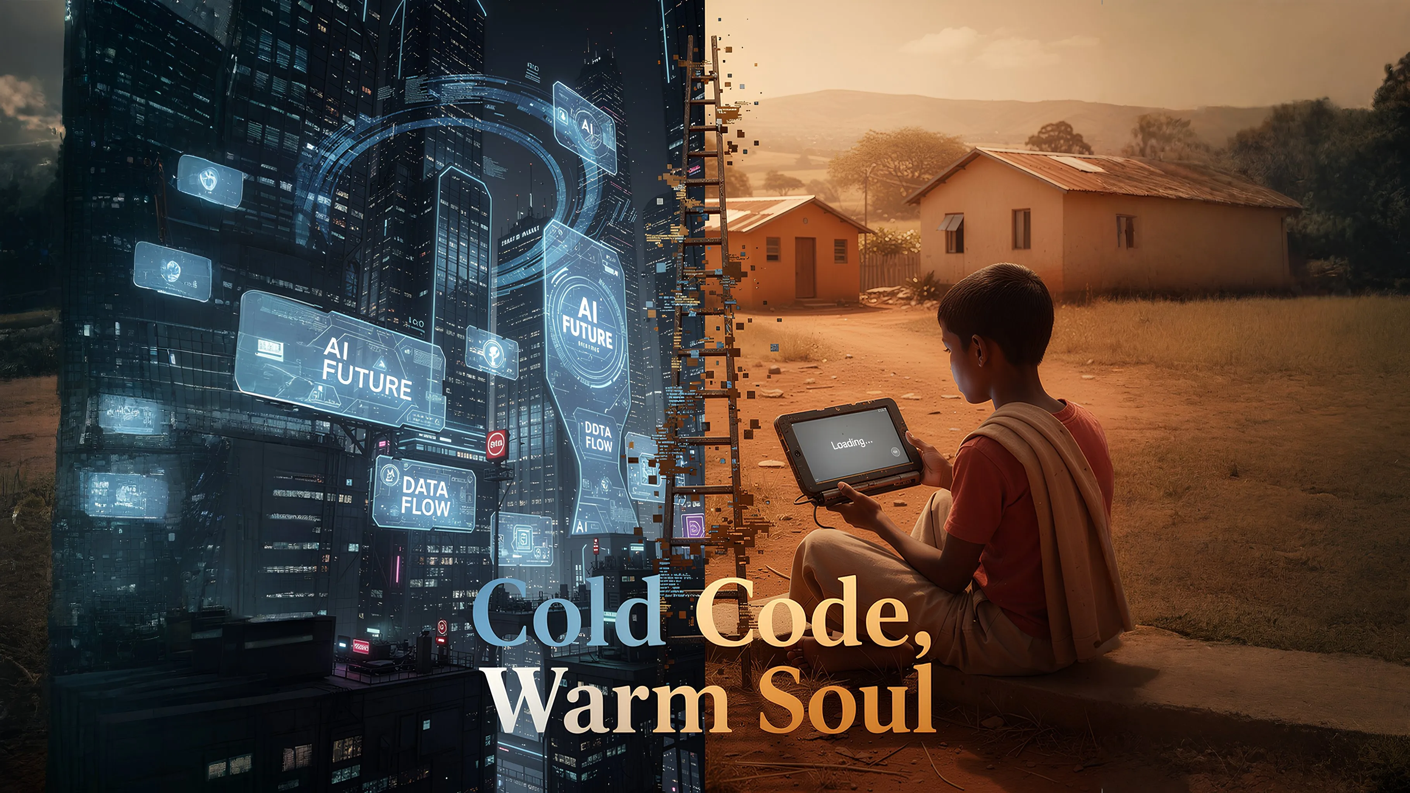

But now, that ladder is shaky.

**Scenario: A Day in the Life of Two Young People**

|  |  |  |
| --- | --- | --- |
| **Category** | **🇺🇸 Developed Country Youth A** | **🌍 Global South Youth B** |
| Morning | Editing resume with ChatGPT | Exceeding daily limit on free version AI |
| Afternoon | Completing coding project with Copilot | Only basic searches possible with slow internet |
| Evening | Learning a new language with an AI tutor | Starting a side hustle as a data labeler for an AI company |

How much wider will the competitiveness gap between the two young people be in a year?  
Will this gap be recoverable in five years?

**The moment intelligence becomes monetized, equality of opportunity becomes a myth.**

─────────────────────────────────────────────────────────────────

### 2.3 Generational Conflict: Wealth in the Older Generation, Where Are the Opportunities?

Most of the world's wealth is concentrated in the older generation. This may be a natural phenomenon. The problem is that AI **accelerates** this imbalance.

The AI Paradox:

* The most creative potential for AI lies with the young generation
* Capital to purchase AI is concentrated among the older generation
* Consequently, AI provides even more leverage to existing wealth holders.

Young people are worried about their jobs being replaced by AI, while simultaneously being denied the opportunity to utilize AI. This double marginalization is deepening intergenerational conflict worldwide.

─────────────────────────────────────────────────────────────────

### 2.4 Human Alienation: What Disappears in the Shadow of Efficiency

AI maximizes efficiency: faster, more accurately, and cheaper.

However, some values are being pushed aside under the logic of efficiency:

* Empathy: Understanding emotions takes time
* Solidarity: Helping others is inefficient
* Relationships: True bonds cannot be measured

"In an era where AI replaces human work, how will humans prove their worth?"

We must answer this question. Otherwise, a paradoxical future will arrive in which technology advances but humans are marginalized.

─────────────────────────────────────────────────────────────────

### The Core of the Problem

|  |
| --- |
| *⚠️ The Core of the Problem  Capital monopolizes intelligence. Inequality of intelligence leads to inequality of opportunity. Inequality of opportunity leads to loss of hope. As the number of young people who lose hope increases, the future of the planet becomes bleak.* |

**AlmaNEO was born to break this chain.**

─────────────────────────────────────────────────────────────────

*The following section explains the philosophy and values AlmaNEO pursues.*

## 3. Our Philosophy: What We Believe

### Technology is a tool. Humans are the subject.

AlmaNEO is not a simple token project. We offer a single answer to the question of how humans should live in the AI era.

--

### 3.1 Jeong (情): From Korea to the World

In Korea, there is a word called "Jeong (情)".

Jeong is not simply kindness. It is a deep bond built over time, a heart that connects without words, and a warmth that cannot be ignored even when loss occurs. Jeong cannot be explained by efficiency. It cannot be measured by calculations. However, a relationship based on Jeong is stronger than any contract.

AI seeks to optimize everything: faster, cheaper, and more efficiently. However, Jeong is not an object of optimization. Jeong takes time. Jeong is sometimes inefficient. Therefore, Jeong is a uniquely human value that AI cannot replace.

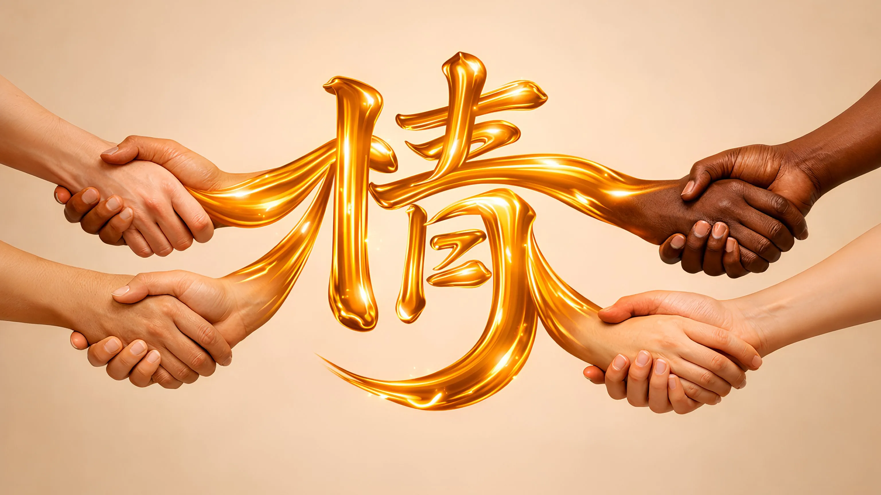

**AlmaNEO embodies this value of "Jeong" in the digital world.**

─────────────────────────────────────────────────────────────────

### 3.2 Three Core Principles

#### Principle 1: People, Not Politics

We don't look at countries. We look at people.

A person's worth is not determined by where they were born or what government they live under. A young person in Nigeria, a young person in Vietnam, a young person in Brazil—they all deserve the same dream.

AlmaNEO is not bound by political ideology or national borders. Our standard is simple:

|  |
| --- |
| *"Does this person want a better future?"\*\** |

If so, we are on their side.

#### Principle 2: Individuals, Not Countries

The grand system sees individuals as numbers. GDP, unemployment rates, growth rates—the lives of individuals are invisible in these statistics.

But statistics miss something. A young man in Lagos learning to code overnight, a college student in Manila working a side job to support his family, a graduate from Bogota dreaming of opening a small business—their efforts and hopes cannot be reduced to numbers.

**AlmaNEO sees individuals, not statistics. It helps people, not systems.**

#### Principle 3: Technology is a tool, humans are the subject

No matter how advanced AI becomes, the final decision must be made by humans.

Technology should not dominate humans, but humans should be the subjects of technology. AlmaNEO does not deify AI. AI is simply a powerful tool. It is up to us humans to decide how to use it.

─────────────────────────────────────────────────────────────────

### 3.3 A World Where Kindness Becomes Value

In the current economic system, kindness is not rewarded.

You could earn money by helping someone. You could monopolize knowledge instead of sharing it. You could compete instead of uniting. Kind people often lose out.

**AlmaNEO turns this equation on its head.**

|  |  |  |
| --- | --- | --- |
| **Classification** | **Existing System** | **AlmaNEO System** |
| Action and Result | Monopoly → Profit Sharing → Loss | Sharing → Increased Kindness Score → More Opportunities |
| Direction | Competition → Success Solidarity → Inefficiency | Solidarity → Accumulation of Trust Assets → Increased Influence within the Ecosystem Kindness → On-chain Record → Real Rewards |

The more you help others, share knowledge, and contribute to the community, the more your value increases. This is the new economy designed by AlmaNEO.

─────────────────────────────────────────────────────────────────

### 3.4 The Future We Dream of

Ten years from now, we envision a world like this:

* A young Nigerian developer freely uses AI tools to launch a startup that solves African agricultural problems.
* A Vietnamese university student connects with a young Brazilian using Kindness Score and starts a business together.
* The Kindness Expo, which began in the DMZ, travels to underprivileged regions around the world, spreading hope.
* "What is your Kindness Score?" becomes a more important question than "What is your education?"

**Is this just a pipe dream?**

When the internet first emerged, a world with a global connection was a distant dream. When Bitcoin first emerged, a stateless currency seemed impossible.

Making the seemingly impossible possible—that's the power of technology. And guiding that technology in the right direction—that's the role of humans.

─────────────────────────────────────────────────────────────────

### Our Manifesto

|  |
| --- |
| *"We plant warm affection on cold code." The ultimate goal of technology lies in humanity. The ultimate goal of efficiency lies in empathy. At the end of competition, there must be solidarity.* |

AlmaNEO will embody this belief in code,  
realize it with tokens,  
and prove it through the community.

─────────────────────────────────────────────────────────────────

*The following sections describe specific solutions within the AlmaNEO ecosystem.*

## 4. Solution: AlmaNEO Ecosystem

### A New World Built on Three Pillars

AlmaNEO builds three core components to address AI inequality. Each component operates independently, yet interconnects to form a single ecosystem.

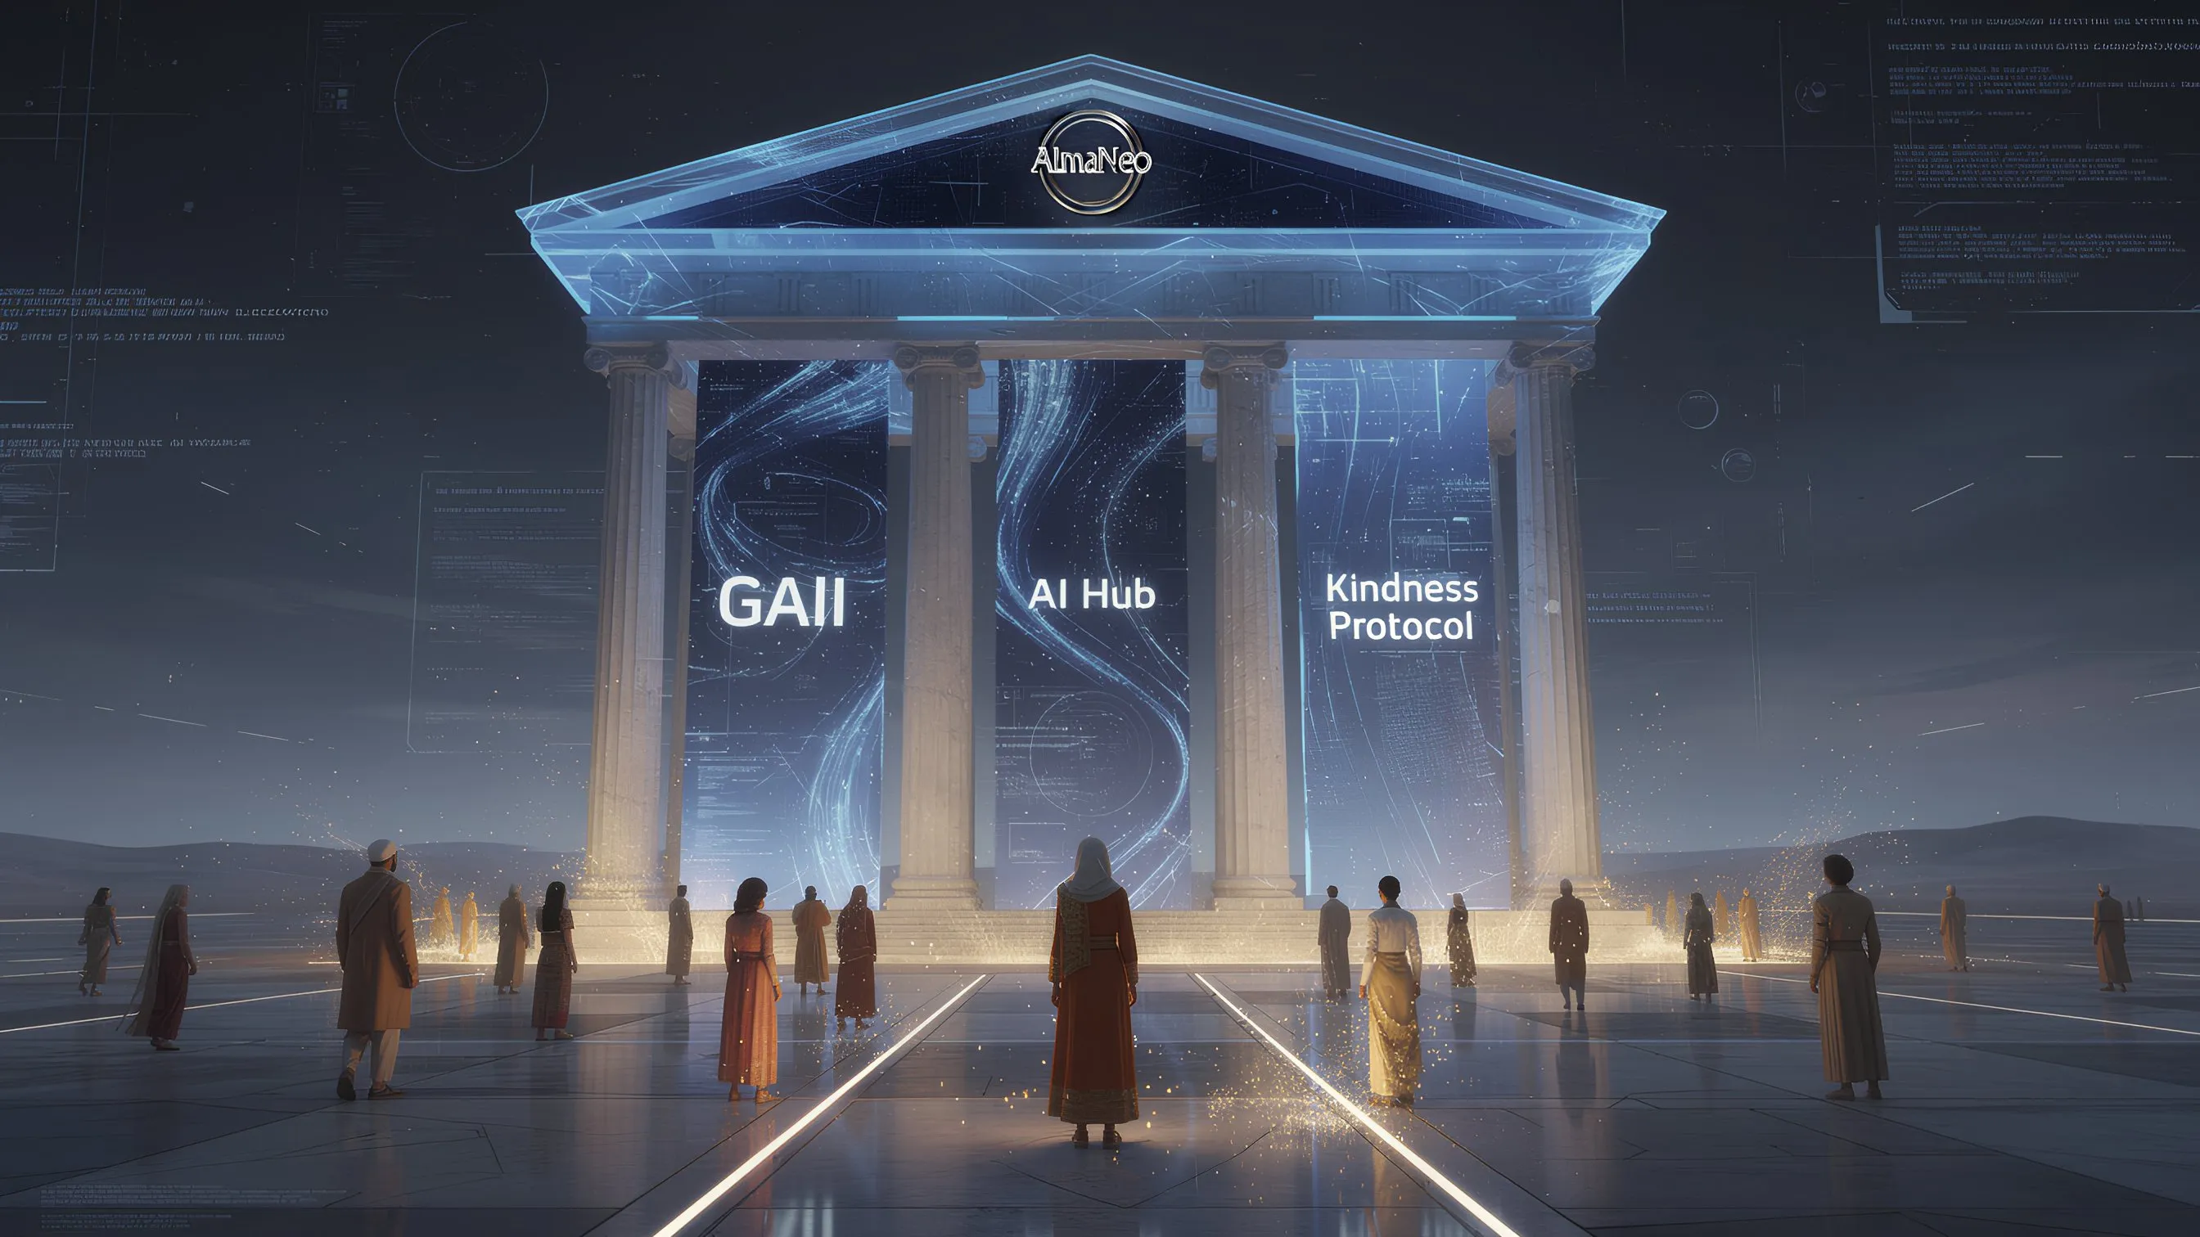

**AlmaNEO Ecosystem Structure:**

|  |  |  |
| --- | --- | --- |
| **Components** | **Roles** | **Connections** |
| GAII | Measurement | Interconnection with AI Hub and Kindness Protocol |
| AI Hub | Provisioning | Interconnection with GAII and Kindness Protocol |
| Kindness Protocol | Rewards | Interconnection with GAII and AI Hub |

All three components are connected by **ALMAN TOKEN** (a medium of value).

─────────────────────────────────────────────────────────────────

### 4.1 GAII (Global AI Inequality Index)

#### If you can't measure it, you can't improve it

GAII is a transparent index that measures and discloses the current state of AI inequality around the world in real time.

#### Measurement Items

|  |  |
| --- | --- |
| **Category** | **Detailed Indicators** |
| Accessibility | Per capita AI service usage by country, ratio of AI subscription fees to average income |
| Infrastructure | GPU computing resource share by country, data center distribution |
| Bias | Language-based performance gaps in AI models, cultural bias |
| Opportunity | Distribution of AI-related jobs, investment rate in AI startups |

#### Role of GAII

**1. Status Visualization**  
- Real-time visibility of AI inequality across the globe through a dashboard.  
- Visualization of data by country, region, and age.

**2. Urging Corporate Responsibility**  
- Publicly discuss the social responsibility of companies monopolizing AI resources  
- Grant an "Ethical AI Label" to companies that contribute to reducing inequality

**3. Providing Policy Basis**  
- Provide objective data to international organizations and governments for AI policymaking  
- Utilize as a new indicator for ESG evaluations

#### Openness Principle

All GAII data is recorded on-chain and verifiable by anyone. We do not monopolize data. To address inequality, we must first transparently expose it.

─────────────────────────────────────────────────────────────────

### 4.2 AlmaNEO AI Hub

#### Intelligence for All, Technology That Excludes No One

The AlmaNEO AI Hub is a platform where young people around the world can access AI without worrying about costs.

#### Key Features

**1. Free AI Access**  
- Provide optimized open-source AI models (Gemma, Llama, etc.)  
- Basic usage is free, and additional usage is paid for with ALMAN tokens

**2. Multilingual Optimization**  
- Overcoming the English-centric AI bias  
- Support for local languages, including Vietnamese, Hindi, Swahili, and Portuguese  
- Local communities directly participate in model improvement

**3. Low-Spec Optimization**  
- Usable even on less-than-modern smartphones or fast internet  
- Supports lightweight models and offline mode

#### DePIN: Distributed Computing Infrastructure

AlmaNEO AI Hub's computational resources are built not by the data centers of large corporations, but by the participation of users around the world.

### How DePIN Works

1. 🖥️ Users in developed countries: "Share your spare GPU resources with the AlmaNEO network."

2. ↓ Provide computational resources

3. AlmaNEO Network: ALMAN token rewards to participants

4. ↓ Provide free AI services

5. 🌍 Global South Youth: "Achieve your dreams with AI at no cost."

**Meaning of DePIN:**  
- AI operated by citizens' computers, not servers owned by large corporations  
- Resources are rewarded, and those in need can use them for free  
- A true "AI infrastructure for humanity"

#### Accessibility Principle: Zero Barrier

The AlmaNEO AI Hub promises the following:

|  |  |
| --- | --- |
| **Barriers** | **AlmaNEO's solution** |
| Complexity of wallet creation | Start in 5 seconds with just a social media account using Web3Auth |
| Gas fees | Basic transactions are covered by the foundation (Gasless) |
| Language barriers | Provides interfaces in major local languages |
| Device performance | Optimized for low-end devices, web-based access |

─────────────────────────────────────────────────────────────────

### 4.3 Kindness Protocol

#### Prove and reward kindness

The Kindness Protocol is the core of the AlmaNEO ecosystem. Beyond simply providing AI, it encourages and rewards "humane use."

#### Proof of Humanity: Proof of Humanity

Existing blockchain consensus methods:  
- Proof of Work: Prove computational power  
- Proof of Stake: Prove capital

AlmaNEO's consensus method:  
- **Proof of Humanity**: Prove humanity

**"Prove not how much you have, but how much you share."**

#### Kindness Score: Kindness Score

Quantifies the good deeds that occur within the community.

**How to earn points:**

|  |  |  |
| --- | --- | --- |
| **Activity** | **Description** | **Score example** |
| Mentoring | Helping other users learn | +10~50 |
| Knowledge Sharing | Creating tutorials and guides | +20~100 |
| Translation Contribution | Participating in localizing AI models | +15~80 |
| Community Support | Answering questions and helping with troubleshooting | +5~30 |
| Social Contribution | Solving local problems using AI | +50~200 |

#### Verification System: Trustworthy Kindness

Multi-layer verification to prevent manipulation of kindness scores:

|  |  |  |
| --- | --- | --- |
| **Steps** | **Process** | **Contents** |
| Step 1 | Activity Record | Users submit proof of their kindness activities |
| Step 2 | Peer Review | Community members verify the authenticity of activities |
| Step 3 | On-chain Record | Verified activity is permanently recorded as SBT (Soulbound Token) |
| Security | ZKP implementation | Privacy protection with zero-knowledge proof |

#### Benefits of Kindness Score

Users with a high Kindness Score:

* More AI Resources: Priority access to advanced models, additional free credits
* Governance Influence: Higher weighting in DAO voting
* Kindness Expo Participation: Priority invitations to annual global events
* Networking Opportunities: Connect with Kindness leaders around the world

#### Jeong-SBT: Non-transferable Soul Token

Kindness Score is recorded as **Jeong-SBT (Jeong Soulbound Token)**.

**SBT Features:**  
- Non-transferable: Kindness cannot be bought or sold.  
- Permanent Record: Your contributions remain on the blockchain forever.  
- Identity Verification: A New ID Card for the AI Era

|  |
| --- |
| *"In the AlmaNEO ecosystem, Jeong-SBT demonstrates who you are. Not your academic background or wealth, but how kind you are."* |

─────────────────────────────────────────────────────────────────

### Synergy of Three Pillars

GAII, AI Hub, and Kindness Protocol are not independent. They work together to create a virtuous cycle.

**Virtuous Cycle Process:**

1. GAII measures inequality.

2. AI Hub allocates resources to underserved areas.

3. Kindness Protocol encourages proper use.

4. Kind users help others.

5. More people benefit from AI.

6. GAII Index improves.

7. (Circle back to 1)

**This is the new AI economy designed by AlmaNEO.**

─────────────────────────────────────────────────────────────────

*The following section describes the technical architecture that implements this ecosystem.*

## 5. Technical Architecture

### Even if the technology is complex, the experience should be simple.

AlmaNEO's technical design principle is clear: **Users don't need to know anything about blockchain.** Complex technology operates behind the scenes, and users use the service in a familiar way.

─────────────────────────────────────────────────────────────────

### 5.1 System Overview

**AlmaNEO System 4-Layer Architecture:**

|  |  |  |
| --- | --- | --- |
| **Layers** | **Components** | **Roles** |
| 1. User Layer | AlmaNEO app, Web3Auth, AI chat interface | Direct user interaction |
| 2. Intelligence Layer | AI model serving, DePIN network, model localization | AI service provision |
| 3. Trust Layer | Kindness Score, biometric authentication, Jeong-SBT issuance | Identity and contribution verification |
| 4. Blockchain Layer | Polygon Network, ALMAN Token, Smart Contracts | Decentralized Infrastructure |

**Data Flow:** User Touchpoint → Intelligence → Trust → Blockchain (Bidirectional Communication Between Layers)

─────────────────────────────────────────────────────────────────

### 5.2 Blockchain: Why Polygon

AlmaNEO is built on the **Polygon Network**.

#### Reasons for Selection

|  |  |
| --- | --- |
| **Criteria** | **Polygon Advantages** |
| Gas Fee | Less than $0.01 per transaction — Affordable even for users in the Global South |
| Speed | Transaction Confirmation within 2 seconds — Real-time Interaction |
| Ecosystem | Mature DeFi, NFT Ecosystem — Scalable |
| Compatibility | Fully Compatible with Ethereum — Easy to Expand |
| Environment | Energy Efficient Based on PoS — Sustainable |

#### Smart Contract Structure

### Smart Contract Structure

|  |  |  |
| --- | --- | --- |
| **Contract** | **Description** | **Main Role** |
| ALMAN Token | ERC-20 standard token | Total supply: 8 billion, AI credit/staking/governance utility |
| Jeong-SBT | ERC-5484 (SBT) | Non-transferable soul token, Kindness Score on-chain record |
| Kindness Registry | Activity Verification Contract | Kindness activity verification and recording, peer-verified voting system |
| Compute Agreement | Resource Sharing Contract | DePIN node registration and rewards, automated computational resource allocation |
| Governance | DAO Contract | DAO proposal and voting, Kindness Score weighted voting rights |

─────────────────────────────────────────────────────────────────

### 5.3 User Experience: Zero Barrier Design

#### Web3Auth: Startup in 5 Seconds

The biggest barrier to entry in existing blockchain services is "wallet creation." Write down your 12 seed phrases, never lose them, and keep your private keys safe. Most people give up here.

**AlmaNEO is different.**

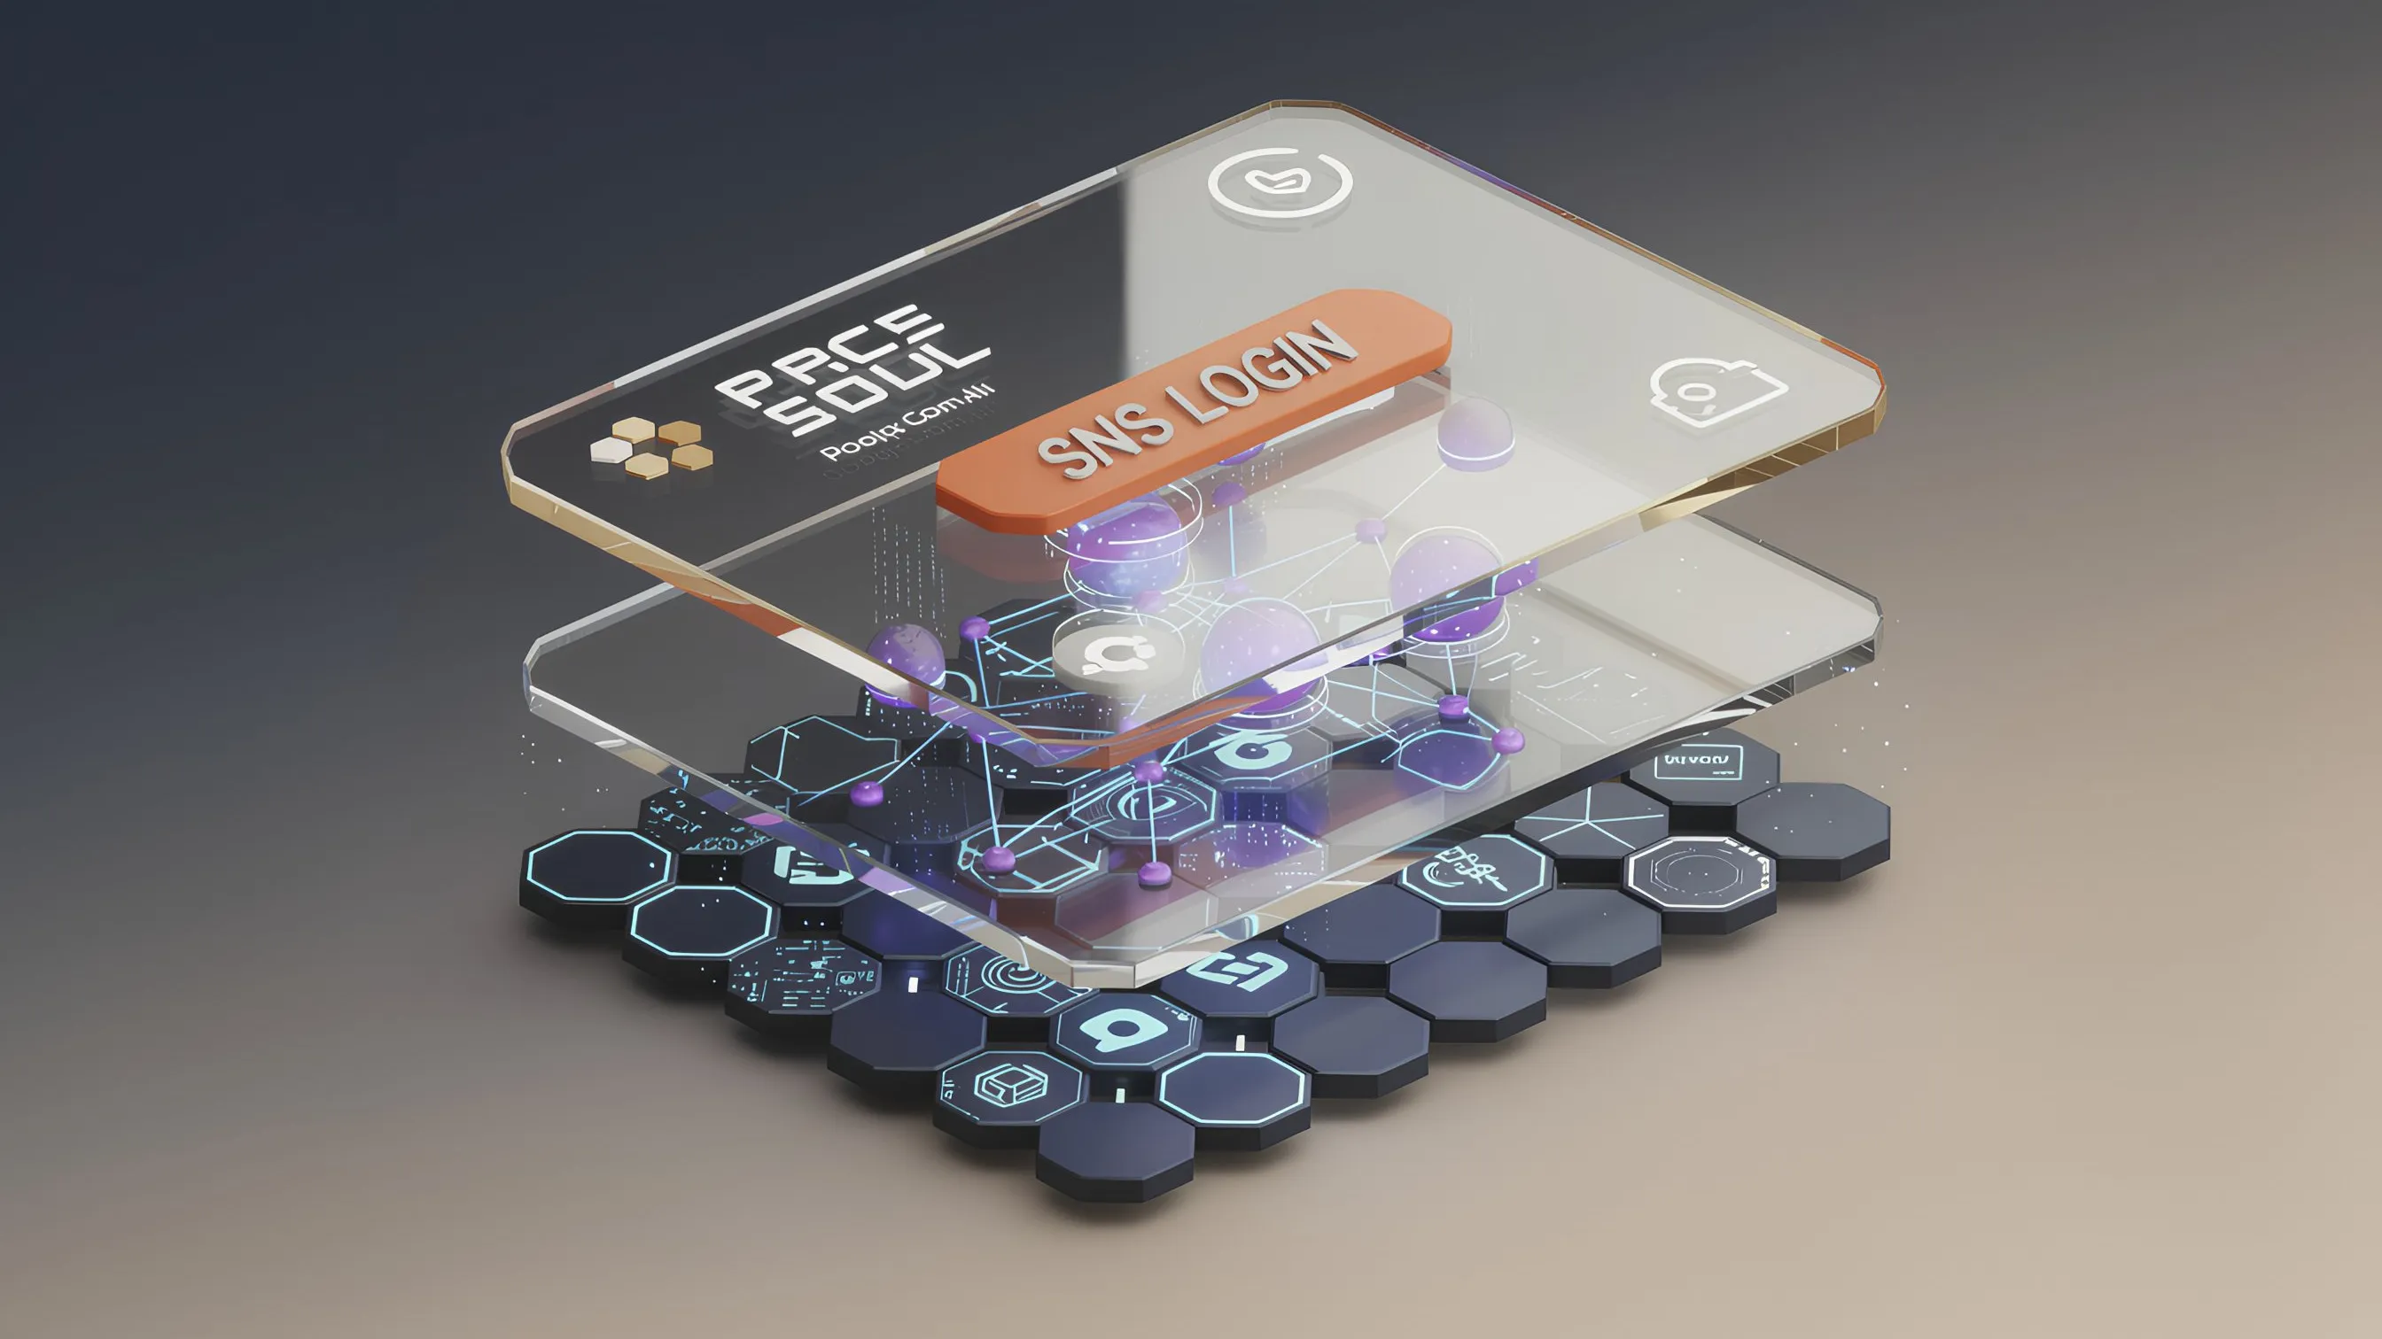

### Comparison of Traditional vs. AlmaNEO Onboarding

|  |  |  |
| --- | --- | --- |
| **Category** | **Traditional Blockchain Onboarding** | **AlmaNEO Onboarding** |
| Procedure | Install wallet → Generate seed phrase → Store safely → Copy address → Purchase tokens → Send → Charge gas fee → Use service (8 steps) | Click "Log in with Google" → Complete (2 steps) |
| Time required | 30 minutes to 1 hour | 5 seconds |
| Bounce rate | 90% or more | Minimal |

**How it works:**  
- Web3Auth automatically creates a non-custodial wallet based on the user's social media account.  
- Private keys are stored in a decentralized manner, making them inaccessible to neither the user nor AlmaNEO.  
- Users can use all features without being aware of the wallet's existence.

#### Gasless Transactions: No Fee Concerns

Another barrier to blockchain adoption is "gas fees." Having to pay a fee for every transaction, no matter how small, can be a significant burden for new users.

**AlmaNEO's Solution:**  
- ERC-4337 (Account Abstraction) is applied.  
- The foundation covers the gas fee for basic transactions.  
- Users can use the service without fees.

─────────────────────────────────────────────────────────────────

### 5.4 AI Infrastructure: Distributed and Optimized

#### Model Optimization

The AlmaNEO AI Hub provides optimized open-source AI models.

|  |  |  |
| --- | --- | --- |
| **Technology** | **Description** | **Effect** |
| Quantization | Model Precision Adjustment | 70% reduction in capacity, 99% performance |
| LoRA | Lightweight fine-tuning | Local language optimization |
| Edge Computing | On-device computation | Available even when the internet is unstable |

#### DePIN Node Operation

Users around the world connect their computers to the AlmaNEO network to provide computational resources.

How to Participate in a Node:

1. Install the AlmaNEO Node software (Windows, Mac, Linux)

2. Set the amount of resources to share (GPU, CPU, storage)

3. Connect to the network

4. Receive ALMAN token rewards based on the amount of resources provided.

**Security:**  
- All computations run in a sandbox environment within a Docker container.  
- User data is protected with end-to-end encryption (E2EE).  
- Even node operators cannot view user queries.

─────────────────────────────────────────────────────────────────

### 5.5 Identity Verification: Humans, Not Bots

Providing AI resources for free inevitably leads to abuse attempts. Bots will create tens of thousands of accounts to monopolize resources.

AlmaNEO implements the **"One Person, One Account"** principle through technology.

#### Multi-Layer Proof of Personhood

### Multi-Layer Proof of Personhood

1. Layer 1: Device Authentication

2. Duplicate device detection using Device Fingerprint

3. Layer 2: Social Authentication

4. Basic identity verification by linking social media accounts

5. Layer 3: Biometric Authentication (Optional)

6. Achieve higher ratings with Face ID and other authentication methods

7. Layer 4: Behavioral Analysis

8. Distinguish between bots and humans based on usage patterns

9. Layer 5: Community Endorsement

10. Increased trust through recommendations from existing members

**Rating System:**

|  |  |  |
| --- | --- | --- |
| **Rating** | **Authentication Level** | **Daily Free AI Credits** |
| Basic | Social Login Only | 10 times |
| Verified | Device + Social | 50 times |
| Trusted | Added biometric authentication | 200 times |
| Guardian | High Kindness Score | Unlimited |

─────────────────────────────────────────────────────────────────

### 5.6 Privacy: Your data belongs to you

AlmaNEO does not collect user data.

#### Privacy Principles

|  |  |
| --- | --- |
| **Principles** | **Implementation** |
| No-Storage Conversations | AI conversations are not stored on servers |
| Local Encryption | User data is encrypted on-device with AES-256 |
| Anonymous Analytics | Data is fully anonymized for service improvement |
| Utilization of Zero-Knowledge Protocol | Privacy protection when verifying Kindness Score |

|  |
| --- |
| *"We don't know what you asked. All we know is how kind you are."* |

─────────────────────────────────────────────────────────────────

### 5.7 Technology Roadmap Summary

|  |  |  |
| --- | --- | --- |
| **Phase** | **Period** | **Major Developments** |
| Alpha | 2025 Q1-Q2 | Testnet Deployment, Core Function Verification |
| Beta | 2025 Q3-Q4 | Mainnet Deployment, DePIN Node Expansion |
| V1.0 | 2026 Q1 | Official Launch, Multilingual Support |
| V2.0 | 2H26 | Advanced Features, Ecosystem Expansion |

─────────────────────────────────────────────────────────────────

*The following section details the ALMAN token's economic structure.*

## 6. Tokenomics

### 8 Billion Tokens for 8 Billion People

The ALMAN token is not simply a speculative asset. It is a tool for equitably sharing the benefits of intelligence in the AI era and a medium that demonstrates the value of kindness.



─────────────────────────────────────────────────────────────────

### 6.1 Token Basic Information

|  |  |
| --- | --- |
| **Item** | **Content** |
| Token Name | AlmaNEO |
| Ticker | ALMAN |
| Network | Polygon |
| Standard | ERC-20 |
| Total Supply | 8,000,000,000 (8 billion) |
| Decimal Point | 18 decimals |

#### Why 8 Billion?

|  |
| --- |
| *"8 billion people worldwide, one token for one person"* |

The number 8 billion represents the current population of the Earth. This number symbolizes AlmaNEO's philosophy:

* All humans deserve to benefit from AI
* Intelligence should not be monopolized by a few, but shared by all of humanity
* Each and every human being is precious

─────────────────────────────────────────────────────────────────

### 6.2 Token Allocation Structure

**ALMAN Token Allocation (Total 8 billion):**

|  |  |  |
| --- | --- | --- |
| **Allocation Items** | **Ratio** | **Amount** |
| Community & Ecosystem | 40% | 3.2 billion |
| Foundation Reserve | 25% | 2 billion |
| Liquidity & Exchange | 15% | 1.2 billion |
| Team & Advisors | 10% | 800 million |
| Kindness Expo & Grants | 10% | 800 million |

─────────────────────────────────────────────────────────────────

### 6.3 Distribution Details

#### 1) Community & Ecosystem (40% - 3.2 billion ALMAN)

The community owns AlmaNEO. 40% of all tokens will be distributed to ecosystem participants.

|  |  |  |  |
| --- | --- | --- | --- |
| **Purpose** | **Ratio** | **Amount** | **Description** |
| Global South Airdrop | 15% | 1.2 billion | Distributed as free AI credits to youth in underprivileged areas |
| Kindness Mining | 12% | 960 million | Rewards for kindness activities |
| DePIN Node Rewards | 8% | 640 million | Rewards for computational resource providers |
| Community Incentives | 5% | 400 million | Ambassadors, events, bug bounties, etc. |

**Distribution Method:**  
- Airdrop: Phased distribution upon completion of KYC verification  
- Mining: Real-time distribution proportional to activity  
- Node Rewards: Daily settlement based on resource provision

#### 2) Foundation Reserve (25% - 2 billion ALMAN)

Funds for foundation operations and project development.

|  |  |  |  |
| --- | --- | --- | --- |
| **Purpose** | **Percentage** | **Amount** | **Description** |
| Development | 12% | 960 million | Technology development and maintenance |
| Operations | 8% | 640 million | Foundation operating expenses, legal, and infrastructure |
| Strategic Reserve | 5% | 400 million | Emergency and opportunity response |

**Lock Conditions:**  
- First year: 2% unlocked monthly  
- Second year and beyond: 4% unlocked monthly  
- All usage details will be publicly disclosed on-chain.

#### 3) Liquidity & Exchange (15% - 1.2 billion ALMAN)

This allocation is for securing market liquidity and listing on exchanges.

|  |  |  |  |
| --- | --- | --- | --- |
| **Purpose** | **Ratio** | **Amount** | **Description** |
| DEX Liquidity | 10% | 800 million | Liquidity pools such as Uniswap and QuickSwap |
| CEX Listing | 5% | 400 million | Centralized exchange listing reserve |

**Operating Principles:**  
- DEX liquidity will be locked for a minimum of 2 years.  
- CEX listing allocation will be used only when necessary. The remainder will be considered for burning.

#### 4) Team & Advisors (10% - 800 million ALMAN)

This allocation is for incentives for the team and advisors.

|  |  |  |  |
| --- | --- | --- | --- |
| **Target** | **Ratio** | **Quantity** | **Vesting** |
| Core Team | 7% | 560 million | 4-year vesting, 1-year cliff |
| Advisors | 3% | 240 million | 2-year vesting, 6-month cliff |

**Vesting Conditions:**

### Team Token Vesting Schedule

|  |  |  |  |
| --- | --- | --- | --- |
| **Period** | **Ratio** | **Status** | **Description** |
| Year 1 | 0% | 🔒 Lock | 1-Year Cliff: Full team token lockup for 1 year after TGE |
| Year 2 | 25% | 🔓 Unlock | Equal quarterly distribution |
| Year 3 | 25% | 🔓 Unlock | Evenly distributed quarterly |
| Year 4 | 25% | 🔓 Unlock | Evenly distributed quarterly |
| Year 5 | 25% | 🔓 Unlock | Evenly distributed quarterly |
| > Undistributed tokens will be returned to the foundation if you withdraw early. |  |  |  |

#### 5) Kindness Expo & Grants (10% - 800 million ALMAN)

This fund is for spreading kindness around the world and supporting small-scale projects.

|  |  |  |  |
| --- | --- | --- | --- |
| **Purpose** | **Ratio** | **Amount** | **Description** |
| Kindness Expo | 6% | 480 million | Hosting an annual expo and supporting participants |
| AlmaNEO Grants | 4% | 320 million | Funding for projects promoting humanitarianism |

**Operating Method:**  
- Expo Fund: Annual DAO voting determines the venue and budget  
- Grants: Quarterly public offering, with community voting selecting the recipient projects

─────────────────────────────────────────────────────────────────

### 6.4 Token Utility

AlmaNEO tokens are used for various purposes within the ecosystem.

### ALMAN Token Utility

|  |  |
| --- | --- |
| **Category** | **Main Usage** |
| AI Services | Payment with AI Credits when exceeding basic usage, purchasing access to advanced models, requesting priority processing |
| Staking | Depositing collateral when operating a DePIN node, receiving staking rewards, 7-day waiting period for unstaking |
| Governance | Creating DAO proposals (minimum holding required), participating in voting (Kindness Score weighting), participating in key decision-making |
| Ecosystem Participation | Applying to participate in the Kindness Expo, making payments on the NFT marketplace, using partner services |

─────────────────────────────────────────────────────────────────

### 6.5 Value Maintenance Mechanism

#### Burn

Various burn mechanisms are in place to ensure long-term stability of token value.

|  |  |
| --- | --- |
| **Burn Type** | **Description** |
| Service Burn | Partial burn when paying for AI Premium Services |
| ESG Credit Burn | Burn when a company purchases AI Equity Credit |
| Unused Burn | Regular burn of unused tokens, such as those left over from CEX listings |

#### Demand Generation

|  |  |
| --- | --- |
| **Demand Type** | **Description** |
| AI Service | Tokens required to use premium features |
| Corporate Partnership | Token purchase required when a company participates in the ecosystem |
| Staking | Token deposit for node operation and rewards |

#### Burn-and-Mint Equilibrium (BME)

### BME Equilibrium Model (Burn-and-Mint Equilibrium)

**BME Equilibrium Model (Burn-and-Mint Equilibrium):**

|  |  |
| --- | --- |
| **Process** | **Description** |
| Token Burn (Burn) | Tokens are burned upon corporate payment → Supply decreases |
| Token Issuance (Mint) | Distributed to the ecosystem as a reward for kindness activities |
| Equilibrium Goal | Burned amount ≥ Newly Issued amount → Long-term value stability and increase |

─────────────────────────────────────────────────────────────────

### 6.6 Early Investor Protection

#### Anti-Dump Policy

Mechanisms to prevent a sharp drop in token price:

* Team/Investor Allocation: Long vesting period and cliff applied
* Large Sell Limit: Daily sell limit (subject to future DAO voting)
* Transparent Disclosure: Real-time monitoring and disclosure of all large wallet movements

#### Fair Start

* Minimize Private Sale
* Maximize Community Allocation (40%)
* Prevent excessive allocation at TGE

─────────────────────────────────────────────────────────────────

### 6.7 Token Distribution Schedule

### Token Unlock Schedule

| Timing | Phase | Content | Expected Circulating Supply |  
| :--- | :--- | :--- |  
| **TGE** | Launch (2026 Q1) | 1st Community Airdrop: 5%, DEX Liquidity: 10% | **15%** (1.2 billion) |  
| **Year 1** | Growth Phase | Monthly Community Mining Distribution, 2% Monthly Foundation Unlock | **35%** |  
| **Year 2** | Expansion Phase | Team Unlock Begins (Cliff Ends), 4% Monthly Foundation Unlock | **55%** |  
| **Year 3-4** | Stability Phase | Continuous Community Rewards | **100%** (Excluding Burn) |

─────────────────────────────────────────────────────────────────

### Summary: Core Values of the ALMAN Token

|  |  |
| --- | --- |
| **Characteristics** | **Description** |
| Symbolism | 8 billion tokens for 8 billion people |
| Utility | AI services, governance, staking |
| Fairness | 40% community, long vesting period |
| Sustainability | Value preservation through a burn mechanism |
| Transparency | All movements are publicly available on-chain |

|  |
| --- |
| *"Holding ALMAN tokens means joining the movement to preserve humanity in the age of AI."* |

─────────────────────────────────────────────────────────────────

*The following section describes the expansion plans for the AlmaNEO ecosystem.*

## 7. Ecosystem Expansion

### AlmaNEO is not a platform, but a seed

AlmaNEO's ultimate goal is not to operate a single service. We aim to create a foundation where young people around the world can create value on their own. We envision a virtuous cycle where numerous projects will sprout within the AlmaNEO ecosystem, and these projects will in turn enrich the ecosystem.

─────────────────────────────────────────────────────────────────

### 7.1 KINFRI: Kind Friend Network

#### A Trust-Based Global P2P Economy

KINFRI (Kind Friend) is the first expansion project of the AlmaNEO ecosystem. Based on the Kindness Score, it connects young people around the world, enabling **person-to-person trust transactions** rather than trade between countries.

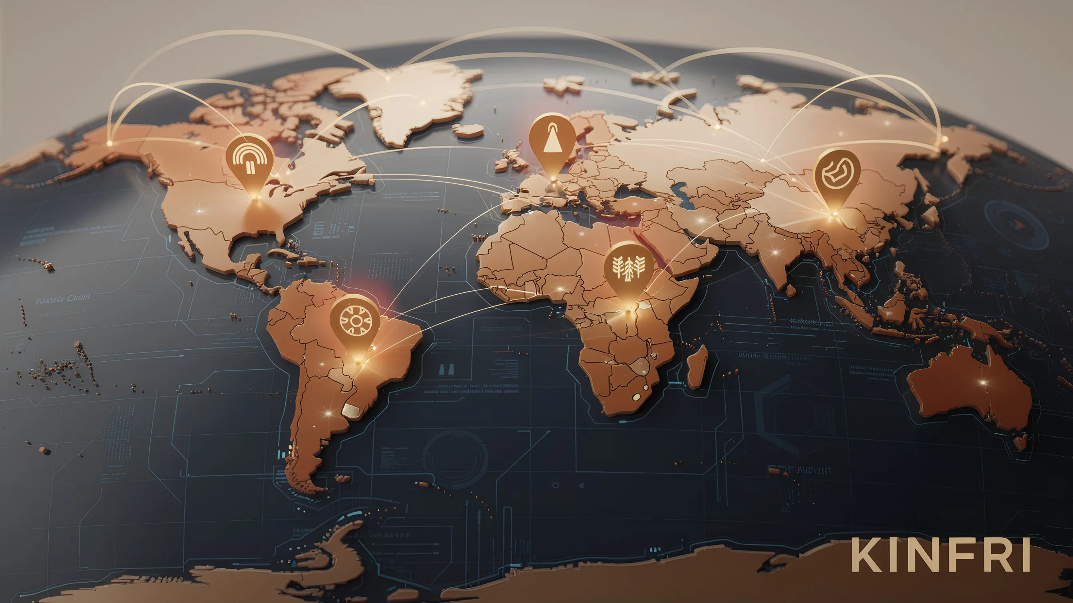

### KINFRI Concept

**KINFRI Concept:**

| Participants | Kindness Score | Roles | |:---|:---:|:---|  
| Vietnamese Youth | 850 | Coffee Cultivation → Sales |  
| Brazilian Youth | 920 | Cafe Operation → Coffee Bean Purchase |

**KINFRI Matching System:**  
- Trust Verification Based on Kindness Score  
- Smart Contract Escrow  
- Dispute Resolution DAO

**Results:** Direct Transactions Without Intermediaries → Fair Prices + Increased Scores on Both Sides

#### KINFRI's Core Values

|  |  |
| --- | --- |
| **Existing Global Trade** | **KINFRI** |
| Country to Country | Person to Person |
| Focused on Large Corporations | Focused on Individuals and Youth |
| Trust Relies on Brands | Trust Proven with Kindness Score |
| Multiple Intermediary Margins | Direct Producer-to-Consumer Transactions |

#### Expandable Areas

KINFRI expands beyond simple commodity trading into various areas:

|  |  |
| --- | --- |
| **Areas** | **Examples** |
| Agricultural Products/Food | Direct Trade in Coffee, Cacao, and Spices |
| Handcrafted Goods | Selling the Works of Local Artisans Worldwide |
| Travel/Accommodation | Homestays with High Kindness Score Hosts |
| Education/Mentoring | Technical Mentoring, Language Exchange |
| Freelance Services | Design, Translation, Development, etc. |

#### Roadmap

KINFRI will be developed through separate, detailed planning after the stabilization of the AlmaNEO mainnet.

|  |  |  |
| --- | --- | --- |
| **Phase** | **Timing** | **Details** |
| Phase 1: Concept Verification | 2nd Half of 2026 | Small-Scale Pilot (Direct Trade in Coffee) |
| Phase 2: Beta Service | 2027 | Opening of 5 Categories |
| Phase 3: Official Launch | 2nd Half of 2027 | Global Expansion |

─────────────────────────────────────────────────────────────────

### 7.2 AlmaNEO Grants Program

#### Investing in projects that practice humanity

AlmaNEO Grants supports small-scale projects that utilize AI to solve social problems.

#### Eligibility

|  |  |
| --- | --- |
| **Terms** | **Description** |
| AI Utilization | Projects utilizing AlmaNEO AI Hub or open-source AI |
| Social Impact | Solving community problems, supporting marginalized groups, etc. |
| Youth-led | Core team members include young people aged 18-38 |
| Open Source | Willingness to share results with the community |

#### Grant Size

|  |  |  |
| --- | --- | --- |
| **Track** | **Grant Funding** | **Target** |
| Seed | $1,000 - $5,000 ALMAN | Idea Stage |
| Growth | $5,000 - $20,000 ALMAN | Prototype Completed |
| Impact | $20,000 - $50,000 ALMAN | Active Project |

#### Selection Process

#### AlmaNEO Grants Selection Process

|  |  |  |
| --- | --- | --- |
| **Steps** | **Process** | **Description** |
| 1 | Application (Quarterly) | Online Application Submission |
| 2 | First Screening | AlmaNEO Foundation Review |
| 3 | Community Voting | Final Selection by DAO Voting |
| 4 | Grant Payment | Milestone-Based Staged Payments |
| 5 | Sharing Results | Results Announcement to the Community |

#### Expected Project Examples

|  |  |  |
| --- | --- | --- |
| **Project** | **Region** | **Content** |
| AI Farm Assistant | Kenya | App for Photo-Based Crop Pest Diagnosis |
| Literacy Chatbot | Bangladesh | Voice-Based Reading/Writing Education |
| Improving Healthcare Access | Philippines | AI Early Diagnosis for Remote Villages |
| Disaster Response System | Indonesia | Natural Disaster Early Warning AI |
| Youth Employment Matching | Nigeria | AI-Based Skill-Job Matching |

#### Giving Back to Successful Projects

Projects that grow through Grants and generate profits voluntarily contribute back to the AlmaNEO ecosystem. This is based on the spirit of **"Giving Back by Feelings"**, not compulsion.

─────────────────────────────────────────────────────────────────

### 7.3 AlmaNEO University

#### AI Literacy, Everyone's Right

AlmaNEO University is an online platform that provides free education on the fundamental skills needed in the AI era.

#### Curriculum

|  |  |  |
| --- | --- | --- |
| **Level** | **Course** | **Content** |
| Level 1 | AI Basics | What is AI, How to Write Prompts |
| Level 2 | AI Utilization | Applying AI to Work/Learning |
| Level 3 | AI Development Fundamentals | Creating Simple AI Apps |
| Level 4 | AI Ethics | Responsible AI Use |

#### Features

* Multilingual Support: Content provided in major local languages
* Community Learning: Learn together through mentor-mentee matching
* Practice-oriented: Real-world projects utilizing the AlmaNEO AI Hub
* Certificate Issuance: On-chain Certificate (SBT) upon course completion

#### Educator Incentives

Contributors who create high-quality educational content are rewarded with ALMAN tokens.

|  |  |
| --- | --- |
| **Contribution Types** | **Rewards** |
| Lecture Content Creation | Per content + proportional to the number of students |
| Translation/Localization | Fixed compensation per language |
| Mentoring Activities | Per hour + Kindness Score |

─────────────────────────────────────────────────────────────────

### 7.4 Partner Ecosystem

#### A Network That Grows Together

AlmaNEO expands its ecosystem by collaborating with like-minded partners.

### AlmaNEO Partner Ecosystem

**AlmaNEO Partner Ecosystem:**

|  |  |
| --- | --- |
| **Partner Types** | **Composition** |
| Technology Partner | AI model providers, blockchain infrastructure, security/audit firms |
| Impact Partner | International organizations (UNESCO/UN), NGOs/NPOs, social enterprises |
| Business Partner | ESG-participating companies, educational institutions, local communities |

#### Partner Benefits

|  |  |
| --- | --- |
| **Partner Types** | **Benefits** |
| Technology Partner | Access to AlmaNEO ecosystem data, joint research opportunities |
| Impact Partner | Priority recommendation for grants, co-hosting of Expo |
| Business Partner | AI Equity Credit, ESG certification support |

─────────────────────────────────────────────────────────────────

### 7.5 Ecosystem Growth Vision

### Ecosystem Growth Vision Roadmap

|  |  |  |
| --- | --- | --- |
| **Timing** | **Phase** | **Key Goals** |
| Year 1 | Seed | Stabilization of AlmaNEO core services, formation of initial community |
| Year 2 | Sprout | KINFRI pilot, first grant success story, launch of AlmaNEO University |
| Year 3 | Tree | 10+ sub-projects, expansion of partner network, self-sustaining ecosystem |
| Year 5+ | Forest | A decentralized ecosystem that operates without AlmaNEO, AlmaNEO in the daily lives of millions of young people around the world, a new standard for the "friendly economy" |

─────────────────────────────────────────────────────────────────

### Our Promise

The AlmaNEO team will not control the platform forever.

Our goal is to grow the ecosystem to a point where it can run on its own, and then fully hand it over to the community. Just as parents raise their children to become independent, AlmaNEO will nurture the ecosystem and set it free.

|  |
| --- |
| *"If we succeed, the name AlmaNEO will one day be forgotten. But a world where kindness is valued will remain. That's enough."* |

─────────────────────────────────────────────────────────────────

*The following section details the Kindness Expo plans.*

## 8. Kindness Expo

### Beyond Online, Kindness Meets Offline

Blockchain and AI are tools for the digital world. However, the "affection" AlmaNEO pursues ultimately blossoms between people. Kindness Expo is a festival where the AlmaNEO community from around the world gathers together to affirm solidarity.

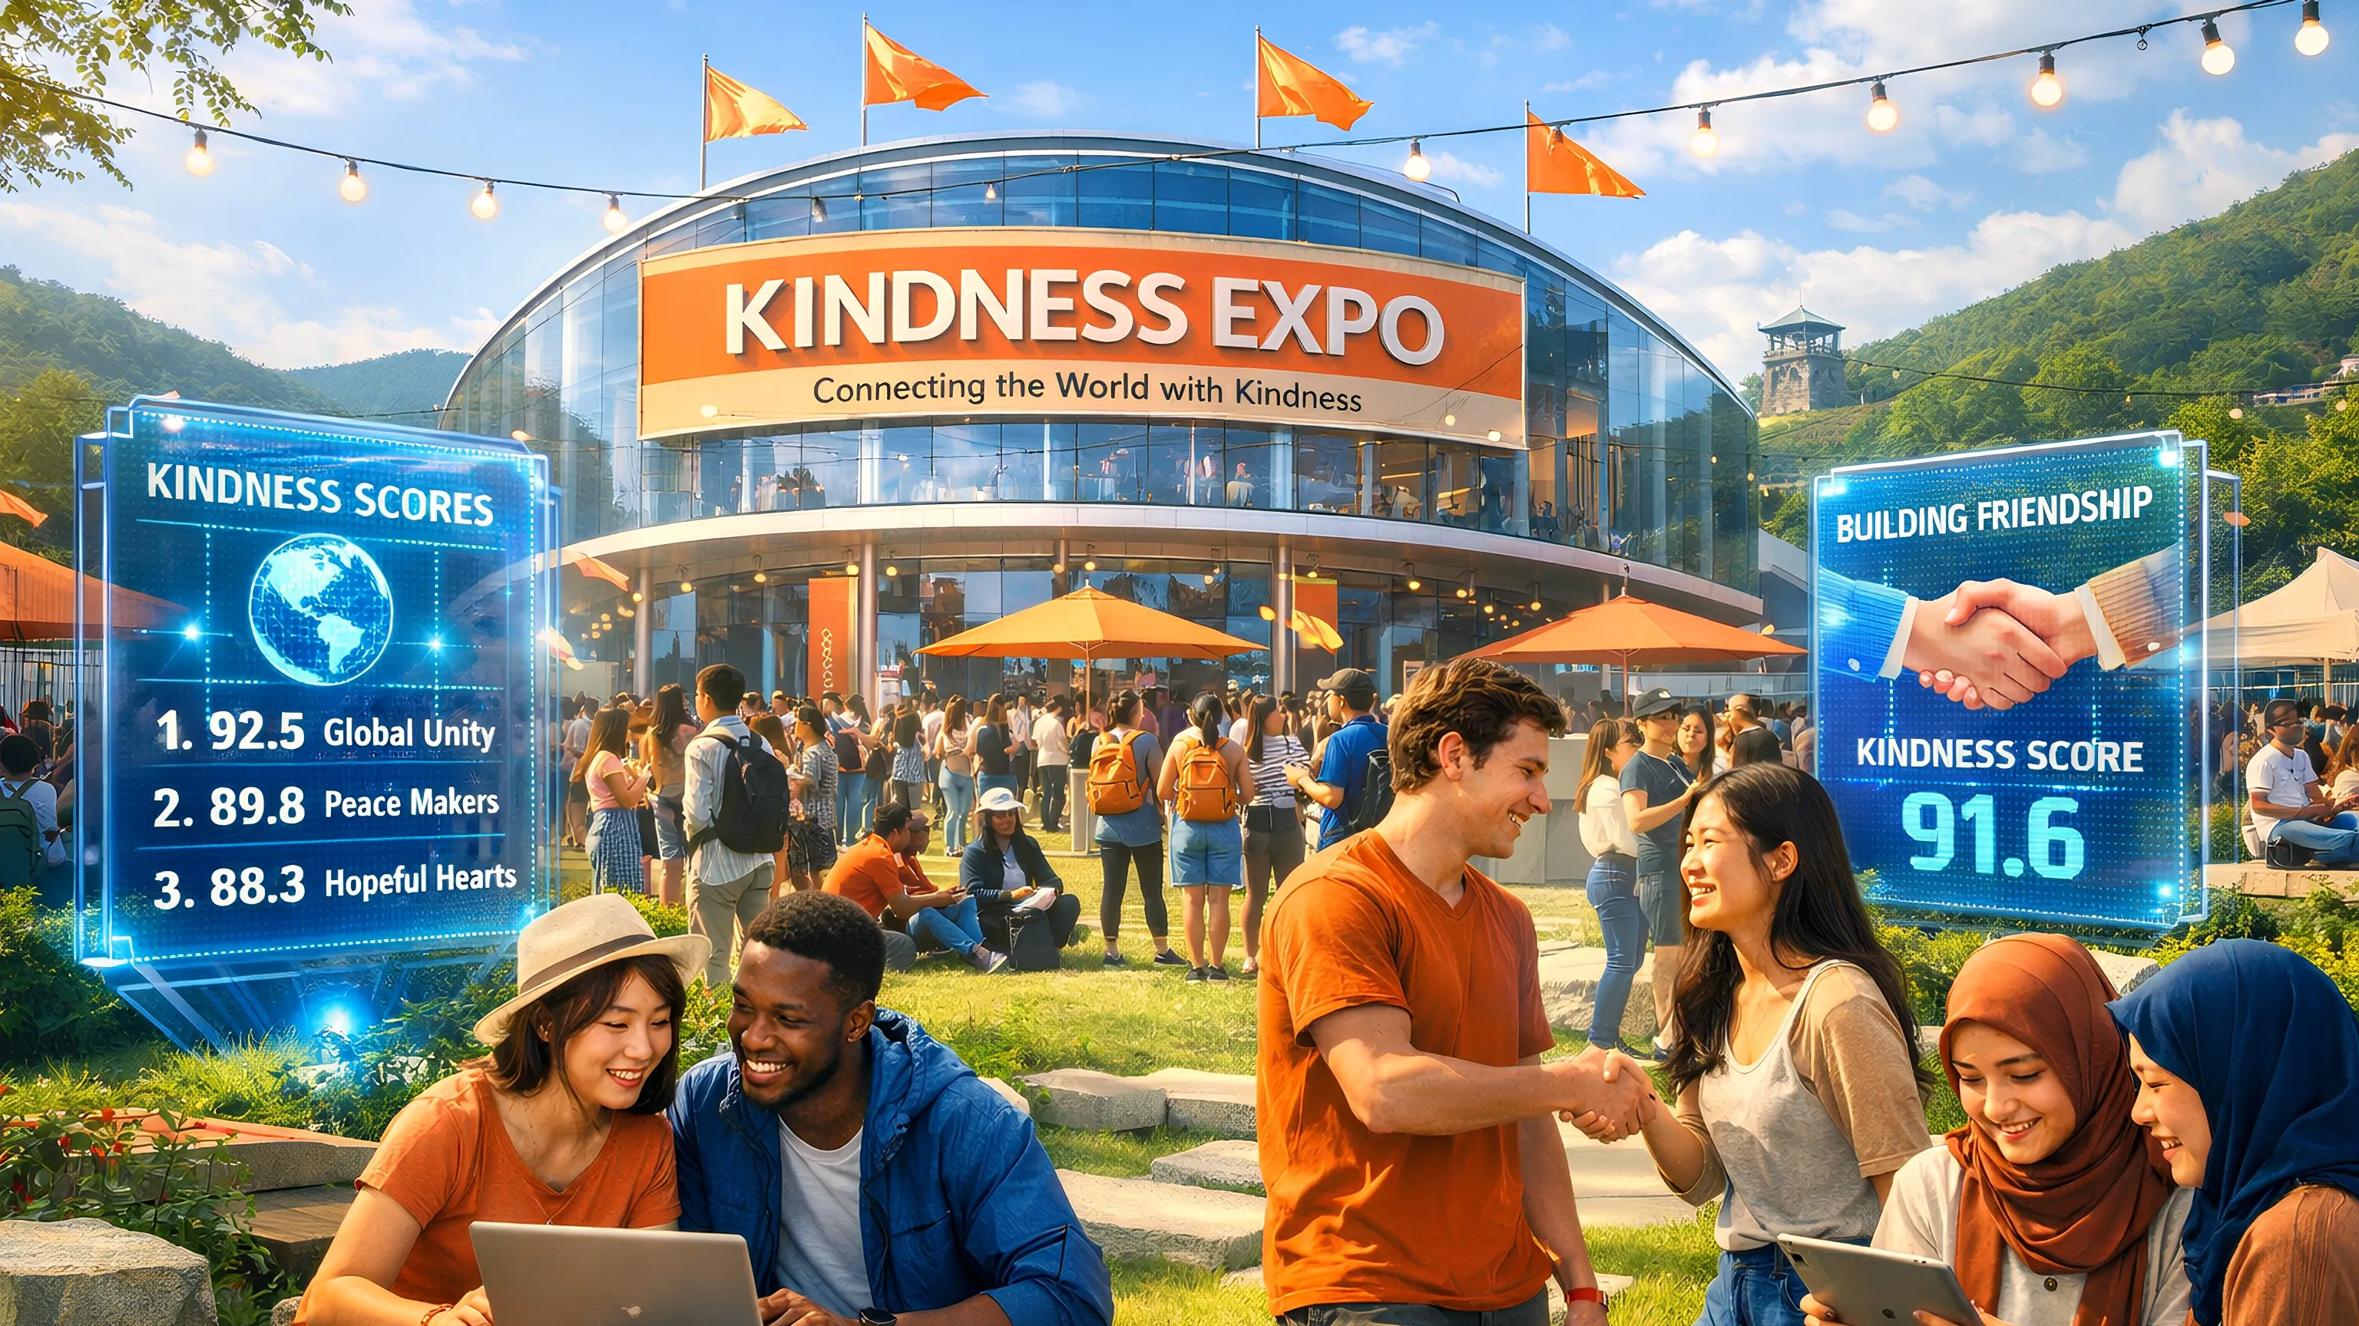

─────────────────────────────────────────────────────────────────

### 8.1 What is Kindness Expo?

Kindness Expo is an annual event of the AlmaNEO community, held in a different city around the world.

#### Event Purpose

|  |  |
| --- | --- |
| **Purpose** | **Description** |
| Connection | A real-life meeting of communities previously only online |
| Inspiration | Sharing the achievements of grant-receiving projects and discovering new ideas |
| Dissemination | Spreading the AlmaNEO philosophy and AI literacy in the host region |
| Celebration | Celebrating and celebrating a year of kindness |

#### Core Program

### Kindness Expo Program

|  |  |
| --- | --- |
| **Program** | **Details** |
| Keynote | AlmaNEO Annual Performance Announcement, GAII Index Change Report, Sharing the Status of Global AI Inequality |
| Kindness Awards | Kindest Person of the Year (Score Top 100 Award), Impact Project of the Year, Node Operator of the Year |
| Workshop & Bootcamp | AI Utilization Practice, Local Youth Bootcamp, Mentor-Mentee Matching |
| Networking | Global Community Exchange, Partner Meeting, Hackathon |
| Festival | Local Cultural Experience, Community Party, Kindness Pledge Ceremony |

─────────────────────────────────────────────────────────────────

### 8.2 Venue Selection Principles

Kindness Expo is held not in a flashy city, but in **places where kindness is most needed**.

#### Selection Criteria

|  |  |  |
| --- | --- | --- |
| **Criteria** | **Description** | **Weighting** |
| AI Accessibility | Priority given to areas with low GAII indices | 30% |
| Youth Population | Percentage of youth population and unemployment rate | 25% |
| Infrastructure | Minimum infrastructure required to host the event | 20% |
| Community | Active local AlmaNEO community | 15% |
| Safety | Candidate safety be guaranteed | 10% |

#### Selection Process

1. City Call for Candidates (DAO Proposal)

2. Community Discussion (2 weeks)

3. DAO Voting (Kindness Score-weighted voting)

4. Final Announcement (6 months prior to the Expo)

─────────────────────────────────────────────────────────────────

### 8.3 Eligibility

Kindness Expo is open to everyone, but **more opportunities are given to kind people**.

| Category | Eligibility | Application Requirements | |------|------|----------|  
| **General Participation** | ALMAN Account Holders | Registration Open |  
| **Invitational Participation** | Top 10% Kindness Score | Partially Covered Flights/Accommodations |  
| **VIP Participation** | Top 1% Kindness Score or Grant Recipients | Fully Covered |  
| **Local Youth** | Youth Residing in the Host City | Free Participation + Bootcamp |

─────────────────────────────────────────────────────────────────

### 8.4 Candidate Sites for the 1st Kindness Expo

The location of the 1st Kindness Expo will be determined by DAO voting. Candidate Sites Currently Under Discussion:

|  |  |  |
| --- | --- | --- |
| **Candidate Sites** | **Characteristics** | **Symbolic Meaning** |
| DMZ (Korea) | AlmaNEO's Founding Site, a Symbol of Division | "Connecting Beyond Division" |
| Nairobi (Kenya) | African Startup Hub | "Hope for the Global South" |
| Da Nang (Vietnam) | A rapidly growing IT city | "Equal Opportunity" |
| Medellin (Colombia) | A city reborn through innovation | "Possibility for change" |

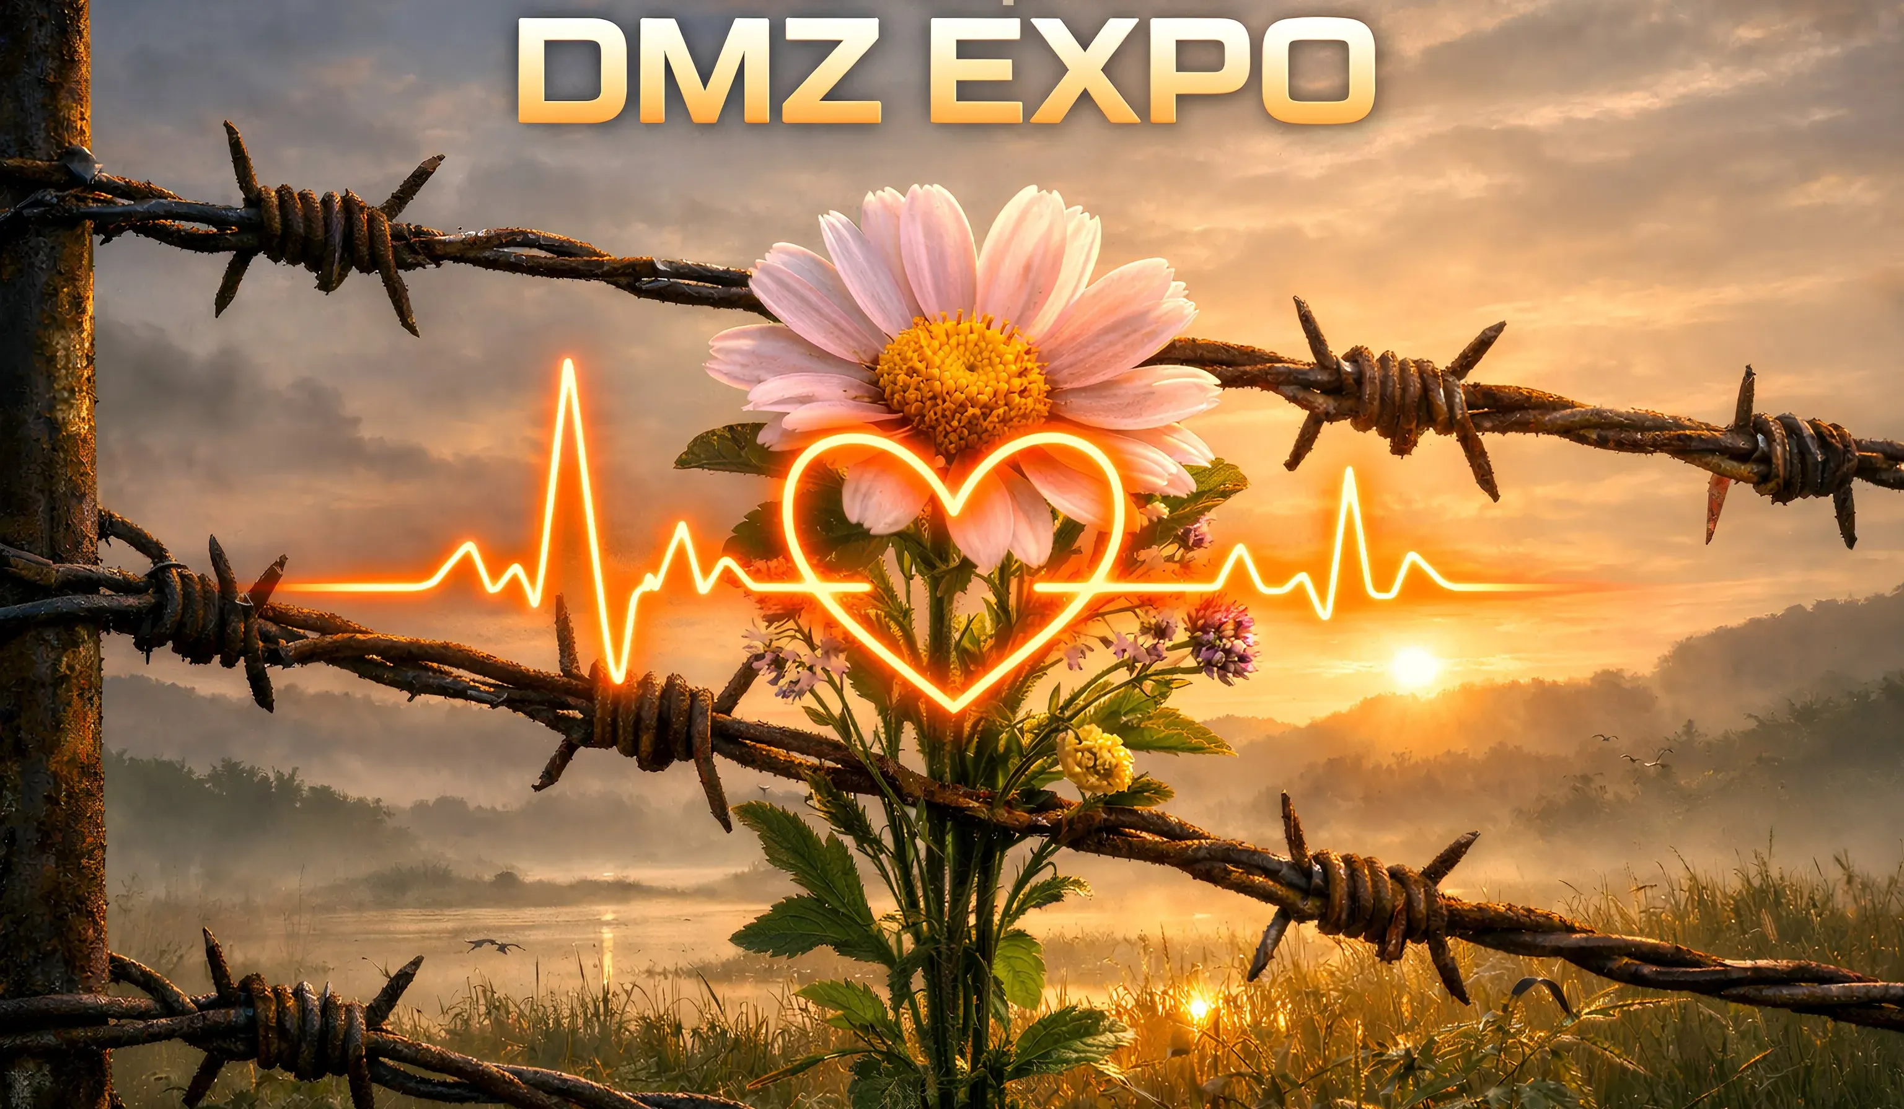

|  |
| --- |
| *The final decision rests with the community.* |

─────────────────────────────────────────────────────────────────

### 8.5 Long-Term Vision

### Kindness Expo Long-Term Roadmap

**Kindness Expo Roadmap:**

|  |  |  |  |
| --- | --- | --- | --- |
| **Year** | **Event** | **Size** | **Features** |
| 2026 | 1st Expo | 500-1,000 attendees | First offline community |
| 2027 | 2nd Expo | 2,000+ attendees | Introducing regional satellite events |
| 2028 | 3rd Expo | Global Brand Growth | Expanding Corporate/Institutional Partnerships |
| 2030+ | AI Davos | Attention from Around the World | Growing into an AI Humanity Forum |

|  |
| --- |
| *"The city hosting the Kindness Expo each year becomes the global capital of kindness that year."* |

─────────────────────────────────────────────────────────────────

*The following section describes AlmaNEO's governance and foundation structure.*

## 9. Governance & Foundation

### Power Must Be Decentralized

AlmaNEO is not a project dominated by any individual or organization. We designed decentralized governance from the ground up, empowering the community to determine its own future.

─────────────────────────────────────────────────────────────────

### 9.1 Governance Philosophy

#### Three Principles

|  |  |
| --- | --- |
| **Principles** | **Description** |
| Transparency | All decision-making processes and financial usage details are publicly available on-chain |
| Participation | Any token holder can propose, vote, and participate in decisions |
| Kindness Weighting | The voice of those who contribute more is stronger than those who simply have more |

─────────────────────────────────────────────────────────────────

### 9.2 DAO Structure

The AlmaNEO DAO gathers the collective intelligence of the community to determine the direction of the project.

### AlmaNEO DAO Structure

**AlmaNEO DAO Structure:**

|  |  |  |
| --- | --- | --- |
| **Composition** | **Roles** | **Description** |
| Token Holders | Entire Community | Proposal Voting Rights, Kindness-Weighted Voting, Council Election |
| Council | Council (9 members) | Urgent Agenda Handling, Proposal Pre-Review |
| Foundation | Foundation | Daily Operations, Legal Representative, DAO Decision Execution |

**Relationship:** Token Holders Elect the Council → Council Cooperates with the Foundation → Foundation Supports/Executes Holders

─────────────────────────────────────────────────────────────────

### 9.3 Voting Mechanism

#### Kindness-Weighted Voting

AlmaNEO's voting system is not simply "1 Token = 1 Vote."

|  |
| --- |
| Voting Power = √(Tokens Held) × Kindness Score Multiplier |

|  |  |
| --- | --- |
| **Kindness Score** | **Multiplier** |
| 0 - 100 | 1.0x |
| 101 - 500 | 1.5x |
| 501 - 1000 | 2.0x |
| 1001+ | 2.5x |

**What this system means:**  
- Limits the monopoly power of whales (large holders)  
- Amplifies the voices of active community contributors  
- A structure where kindness equals influence

#### Proposal Types

|  |  |  |  |
| --- | --- | --- | --- |
| **Type** | **Quorum** | **Passing Requirements** | **Example** |
| General Proposal | 5% | Majority | Small Budget Use, Partnership |
| Important Proposal | 15% | 2/3rds | Expo Hosting, Large Grants |
| Constitutional Amendment | 30% | 3/4ths | Token Economy Changes, Governance Structure Changes |

─────────────────────────────────────────────────────────────────

### 9.4 AlmaNEO Foundation

The Foundation is the legal entity that enforces the DAO's decisions in the real world.

#### Roles

|  |  |
| --- | --- |
| **Role** | **Description** |
| Legal Representative | Contract Execution, Partnerships, Regulatory Response |
| Daily Operations | Development Team Management, Infrastructure Operations |
| DAO Execution | Execution of Community Decisions |
| Asset Management | Foundation Reserve Management (Multi-Signature) |

#### Commitment to Transparency

* Quarterly Financial Reports Disclosure
* All Expenditures Recorded On-Chain
* Annual External Audit Conducted
* Council Oversight Accepted

#### Foundation Establishment Plan

The location of the Foundation will be determined by considering the following factors:

|  |  |
| --- | --- |
| **Factors Considered** | **Description** |
| DAO-Friendly Laws | Jurisdictions that Legally Recognize DAO Activities |
| Tax Efficiency | Taxation Appropriate for Nonprofit Activities |
| Ease of Operation | Possibility of Remote Establishment/Operation |
| Reputation | A Legitimate Innovation Zone, Not a Regulatory Avoidance Zone |

|  |
| --- |
| *The specific establishment location will be finalized and announced after legal review.* |

─────────────────────────────────────────────────────────────────

### 9.5 Gradual Decentralization

AlmaNEO does not pursue complete decentralization from the outset. Rapid decentralization may actually put the project at risk.

### Gradual Decentralization Roadmap

|  |  |  |  |
| --- | --- | --- | --- |
| **Phase** | **Period** | **Features** | **Key Contents** |
| Phase 1 | 2025-2026 | Foundation-led | Establish core infrastructure, form an initial community, and the Foundation makes major decisions |
| Phase 2 | 2026-2027 | Joint Governance | Begins Council elections, DAO voting on major agenda items, and gradual transfer of authority to the Foundation |
| Phase 3 | 2027-2028 | DAO-led | Most decisions are made in the DAO, with the Foundation transitioning to the executive body |
| Phase 4 | 2028+ | Fully decentralized | Foundation minimized or dissolved, smart contract-based automated operation, full community autonomy |

─────────────────────────────────────────────────────────────────

### 9.6 Safeguards

#### Emergency Pause

In the event of a serious security threat or bug, the protocol can be temporarily suspended by a majority vote of the Council (5/9).

The protocol will be resumed or resolved through a DAO vote within 48 hours of the suspension.

#### Multi-Sig

Foundation assets are managed through a multi-signature wallet.

|  |  |
| --- | --- |
| **Purpose** | **Signature Requirements** |
| Daily operating expenses | 3/5 signatures |
| Large expenditures | 5/7 signatures |
| Emergency fund | 7/9 signatures + DAO vote |

#### Timelock

Major smart contract changes are subject to a 48-hour timelock, ensuring the community has time to review and object.

─────────────────────────────────────────────────────────────────

### Ultimate Goal of Governance

|  |
| --- |
| *"Even if the AlmaNEO Foundation disappears one day, the AlmaNEO ecosystem must continue to function. Our success hinges on us becoming obsolete."\** |

─────────────────────────────────────────────────────────────────

*The following section outlines AlmaNEO's specific roadmap.*

## 10. Roadmap

### Step by Step, But Never Stop

AlmaNEO prioritizes execution over grand promises. The roadmap below is the current plan and is subject to adjustment based on community feedback and market conditions.

─────────────────────────────────────────────────────────────────

### 10.1 Full Roadmap Summary

### AlmaNEO Roadmap 2025-2028

**AlmaNEO Core Roadmap:**

|  |  |  |
| --- | --- | --- |
| **Year** | **First Half** | **Second Half** |
| 2025 | Foundation Building (Q1-Q2) | Testnet & Community (Q3-Q4) |
| 2026 | TGE & Mainnet (Q1), Ecosystem Expansion (Q2-Q3) | 1st Kindness Expo (Q4) |
| 2027 | Global Expansion | DAO Conversion |
| 2028+ | Full Decentralization | Self-sustaining Ecosystem |

─────────────────────────────────────────────────────────────────

### 10.2 2025: The Year of Foundation Building

#### Q1 (Jan-March)

|  |  |
| --- | --- |
| **Milestone** | **Details** |
| ✅ White Paper V1 | Finalize Vision, Technology, and Tokenomics |
| 🔄 Grant Application | Gitcoin, Polygon Village, etc. |
| 🔄 Securing the Core Team | Recruiting 2-3 Co-founders |
| 🔄 Legal Review | Selecting a Foundation Establishment Location |

#### Q2 (Apr-June)

|  |  |
| --- | --- |
| **Milestone** | **Details** |
| Smart Contract Development | Token, SBT, Kindness Registry |
| Security Audit Preparation | Selecting an Audit Firm |

#### Q3 (July-September)

|  |  |
| --- | --- |
| **Milestone** | **Details** |
| Testnet Deployment | Polygon Amoy Testnet |
| Smart Contract Audit | External Security Audit Completed |
| AI Hub Alpha | Open Source Model Integration Testing |
| Ambassador Program | Global Ambassador Recruitment |

#### Q4 (October-December)

|  |  |
| --- | --- |
| **Milestones** | **Details** |
| Testnet Launch | Community Testing Begins |
| Bug Bounty | Bug Reporting Reward Program |
| TGE Preparation | DEX Liquidity and Marketing Preparation |
| Kindness Protocol Beta | Scoring System Testing |

─────────────────────────────────────────────────────────────────

### 10.3 2026: The Year of Leap Forward

#### Q1 (January-March)

|  |  |
| --- | --- |
| **Milestones** | **Details** |
| Foundation Establishment | Legal Entity Securing |
| GAII Dashboard Release | Real-Time Release of AI Inequality Index |
| 🚀 TGE (Token Generation Event) | Official ALMAN Token Issuance |
| Mainnet Launch | Polygon Mainnet Distribution |
| DEX Listing | Uniswap, QuickSwap Liquidity Pool |
| Initial Community Formation | Discord and Telegram Launch |
| Expanded Multilingual Support | 14 Language Interfaces |

#### Q2 (April-June)

|  |  |
| --- | --- |
| **Milestones** | **Details** |
| AlmaNEO AI Hub Open Beta | Free AI Service Launch |
| Kindness Mining Launch | Kindness Activity Rewards Beginning |
| DePIN Node Expansion | Targeting 1,000 Node Operators |

#### Q3 (July-September)

|  |  |
| --- | --- |
| **Milestones** | **Details** |
| Council Election Preparation | Governance System Establishment |
| Global South Airdrop | Distribution to Youth in Underserved Areas |
| First Grants Call | Impact Project Recruitment |

#### Q4 (October-December)

|  |  |
| --- | --- |
| **Milestones** | **Details** |
| 🎉 1st Kindness Expo | First Offline Community Event |
| AlmaNEO University Beta | AI Education Platform Test |
| Expanding Partnerships | 10+ Impact Partners |
| Annual Report Publication | First Year Performance Disclosure |
| CEX Listing Promotion | Centralized Exchange Listing Discussion |

─────────────────────────────────────────────────────────────────

### 10.4 2027: The Year of Expansion

|  |  |
| --- | --- |
| **Quarter** | **Key Milestones** |
| Q1 | Council Officially Launched, DAO Governance Initiated |
| Q2 | KINFRI Pilot Launch, AlmaNEO University Officially Launched |
| Q3 | Targeting 1 Million Users, Additional CEX Listings |
| Q4 | 2nd Kindness Expo, 50+ Grant-Receiving Projects |

─────────────────────────────────────────────────────────────────

### 10.5 2028 and Beyond: The Era of Maturity

### Long-Term Vision (2028+)

* 🌍 Global Impact
* Substantial contribution to improving the GAII Index
* Reducing the AI Accessibility Gap by more than 10%
* 100+ Success Stories of Grant Projects
* 🤝 Self-sustaining Ecosystem
* DAO operating independently of the Foundation
* KINFRI growing into an official service
* Operation of multiple AlmaNEO-based sub-projects
* 🏛️ Institutional Recognition
* Partnerships with International Organizations/Governmental Organizations
* Adoption of AI Equity Credit as an ESG Standard
* Expanding Collaboration with Academia/Research Institutes

─────────────────────────────────────────────────────────────────

### 10.6 Milestone Tracking

All roadmap progress will be transparently disclosed through the following:

* Monthly Update: Blog and Newsletter
* Quarterly Report: Detailed Progress
* On-Chain Record: NFT Issuance upon Achieving Key Milestones
* Community Call: Monthly AMA (Ask Me Anything)

|  |
| --- |
| *"We keep our promises, and we don't promise things we can't keep."* |

─────────────────────────────────────────────────────────────────

*The following section introduces the AlmaNEO team.*

## 11. Team & Advisors

### Who We Are

The AlmaNEO team values authenticity over flashy resumes. We don't come from large corporations. We didn't start with the backing of famous investors. We are ordinary, yet passionate people who want to stand on the side of those who are marginalized in the age of AI.

--

### 11.1 Team Philosophy

#### Why We Start Anonymously

The AlmaNEO founding team initially operates anonymously or under pseudonyms.

**Reason:**  
- **Project-centered**: We want to be evaluated based on the value of the project, not on individual reputation.  
- **Fair Start**: We don't rely on academic background, career experience, or connections.  
- **Safety**: We minimize unnecessary personal risks in the early stages.

**Promise:**  
- As the project stabilizes and trustworthy team members are secured, we will gradually disclose real names.  
- Even before real names are disclosed, all decisions and financial use will be transparently recorded.  
- The community can judge a team by its actions.

─────────────────────────────────────────────────────────────────

### 11.2 Founding Team

The AlmaNEO founding team is currently small and is looking for colleagues to join us.

### AlmaNEO Founding Team

|  |  |  |
| --- | --- | --- |
| **Members** | **Roles** | **Background/Status** |
| Founder | Vision Design, Strategy, Community | Experience in the AI/Blockchain industry. "Technology should be for everyone." |
| Co-Founders | Technology/Community/Operations | Recruiting - Experience in Smart Contracts, AI/ML, Global South Networks, Foundations/Legal/Finance |

─────────────────────────────────────────────────────────────────

### 11.3 Collaborators We're Looking for

AlmaNEO is looking for individuals with the following:

#### Requirements

|  |  |
| --- | --- |
| **Requirements** | **Description** |
| Sense of Mission | Interested in impact over financial gain |
| Patience | Preferring the right direction, even if it's slow |
| Collaboration | Desire to grow together rather than shine alone |
| Honesty | Ability to admit mistakes and learn |

#### Preferred Qualifications

|  |  |
| --- | --- |
| **Domain** | **Experience** |
| Technology | Solidity, Web3, AI/ML, DePIN |
| Community | Discord/Telegram management, ambassador experience |
| Language | English + Spanish/Portuguese/Hindi/Swahili, etc. |
| Network | Global South Region Connection |

#### Contact Us

If you're interested in joining, please contact us:  
- **Email**: joinwithus@almaneo.foundation  
- **Discord**: [Coming Soon]  
- **Twitter/X**: [Coming Soon]

─────────────────────────────────────────────────────────────────

### 11.4 Advisors

Almaneo is seeking advisors in the following areas:

|  |  |  |
| --- | --- | --- |
| **Area** | **Role** | **Status** |
| Blockchain/Web3 | Token Economy, Technology Review | Recruiting |
| AI/ML | AI Hub Architecture, Model Optimization | Recruiting |
| Legal/Regulatory | Foundation Establishment, Global Regulatory Response | Recruiting |
| Impact/NGO | Social Impact Strategy, Partnerships | Recruiting |
| Community | Global Community Growth Strategy | Recruiting |

|  |
| --- |
| *Advisor compensation will be paid with a two-year vesting period as specified in the Tokenomics section.* |

─────────────────────────────────────────────────────────────────

### 11.5 Team Expansion Plan

### Team Expansion Roadmap

**Team Expansion Roadmap:**

|  |  |  |  |
| --- | --- | --- | --- |
| **Phase** | **Timing** | **Size** | **Description** |
| Phase 1 | Current | Founding Team | Initial Vision Design |
| Phase 2 | 2026 Q2 | 3-5 people | Core Team Formation |
| Phase 3 | 2026 Q4 | 10-15 people | Global Team Expansion |
| Goal | - | 20-30 people | Efficient and Strong Organization |

─────────────────────────────────────────────────────────────────

### 11.6 Our Promise

The AlmaNEO team pledges the following to the community:

1. Transparent Communication: We share good and bad news honestly.

2. Responsible Rewards: Team tokens unlock over four years and share the project's success and destiny.

3. Community First: We prioritize the community's interests over the team's.

4. Progressive Disclosure: We gradually reveal ourselves as trust builds.

5. Kind Leadership: We practice what we call "kindness" first.

|  |
| --- |
| *"We are not influential people. We are kind people. That's the starting point of AlmaNEO."\** |

─────────────────────────────────────────────────────────────────

*The following section describes the project's risks and countermeasures.*

## 12. Risk Factors & Mitigation

### Honest Warning

The AlmaNEO team believes in being as honest about the risks as the project's potential. This section outlines the risk factors that potential investors and participants should be aware of.

─────────────────────────────────────────────────────────────────

### 12.1 Market Risks

#### Cryptocurrency Market Volatility

|  |  |  |
| --- | --- | --- |
| **Risk** | **Description** | **Response** |
| Price Volatility | Cryptocurrency markets exhibit extreme volatility | Focus on long-term value creation, not short-term price fixation |
| Bear Market | Difficulty in sustaining the project in a prolonged bear market | Targeting operating capital for 18 months or more |
| Lack of Liquidity | Price distortion due to initial low trading volume | DEX liquidity lockup, gradual distribution |

#### Regulatory Risks

|  |  |  |
| --- | --- | --- |
| **Risk** | **Description** | **Response** |
| Regulations in each country | Potential strengthening of cryptocurrency regulations in each country | Compliance with regulations through legal advice, designing a flexible structure |
| Token Classification | Possibility of Securities Classification | Strengthening of Practical Functions as a Utility Token |
| KYC/AML | Strengthening Identity Verification Requirements | Phased KYC Implementation, Balancing Privacy and Compliance |

─────────────────────────────────────────────────────────────────

### 12.2 Technical Risks

#### Security

|  |  |  |
| --- | --- | --- |
| **Risk** | **Description** | **Response** |
| Smart Contract Vulnerability | Loss of Funds Due to Code Bugs | Multi-Security Audit, Bug Bounty Program |
| Hacking | Damage Due to External Attacks | Multi-Signature Wallet, Cold Storage, Insurance Review |
| Privacy Infringement | User Data Leakage | E2EE, Zero Key Proof-of-Purpose, Minimum Data Collection Principle |

#### Technical Implementation

|  |  |  |
| --- | --- | --- |
| **Risk** | **Description** | **Response** |
| Development Delay | Development Delay Compared to Roadmap | Establishing a Conservative Schedule, Clarifying Priorities |
| Scalability | Performance degradation with user growth | Leveraging Polygon's scalability, gradually expanding infrastructure |
| AI model limitations | Performance constraints of open-source models | Continuous model updates, community-based improvements |

─────────────────────────────────────────────────────────────────

### 12.3 Operational Risks

#### Team-related

|  |  |  |
| --- | --- | --- |
| **Risk** | **Description** | **Response** |
| Key personnel departure | Founding member or core developer departure | Team token vesting, knowledge sharing, documentation |
| Failure to scale the team | Difficulty in securing the right talent | Global hiring, remote work, community-based hiring |
| Anonymity risk | Lack of trust in initial anonymous operations | Building trust through actions, gradual real-name disclosure |

#### Funding-related

|  |  |  |
| --- | --- | --- |
| **Risk** | **Description** | **Response** |
| Insufficient funds | Funds depleted due to grant failure or market downturn | Diversified funding strategy, lean operations |
| Failure to manage funds | Inefficient spending or embezzlement | Multi-signature, on-chain transparency, regular audits |

─────────────────────────────────────────────────────────────────

### 12.4 Ecosystem Risks

#### Adoption Related

|  |  |  |
| --- | --- | --- |
| **Risks** | **Description** | **Response** |
| Lack of Users | Insufficient Target User Count | Phased Growth Targets, Focus on Core Users |
| Lack of Network Effects | Difficulty in Creating Value Without Sufficient Participants | Strengthening Initial Incentives, Ambassador Program |
| Competition | Emergence of Similar Projects | Competing with Differentiated Philosophy and Execution |

#### Kindness Score Related

|  |  |  |
| --- | --- | --- |
| **Risks** | **Description** | **Response** |
| System Abuse | Score Manipulation with Fake Kindness Activities | Multi-layer Verification, Community Monitoring, Penalty System |
| Bot/Sybil Attacks | Reward Stealing with Multiple Accounts | Proof of Personhood, Behavioral Analysis |

─────────────────────────────────────────────────────────────────

### 12.5 External Risks

|  |  |  |
| --- | --- | --- |
| **Risk** | **Description** | **Response** |
| AI Technology Change | Rapid advancements in AI technology invalidate strategies | Flexible technology stack, continuous monitoring |
| Global situation | Uncertainty due to war, pandemics, etc. | Distributed teams and infrastructure, crisis response plans |
| Reputational risk | Negative press, FUD | Transparent communication, fact-based response |

─────────────────────────────────────────────────────────────────

### 12.6 Risk Management Principles

### AlmaNEO Risk Management Principles

|  |  |
| --- | --- |
| **Principle** | **Details** |
| 1. Transparency | Disclosure when issues arise, issuing regular risk reports |
| 2. Decentralization | Minimizing single points of failure, decentralizing authority, funds, and knowledge |
| 3. Conservative approach | Avoid overpromising, prepare for worst-case scenarios |
| 4. Community participation | Reward the community when risks are identified, and solve problems through collective intelligence |

─────────────────────────────────────────────────────────────────

### Disclaimer

|  |
| --- |
| *Important: This white paper is for informational purposes only and does not constitute investment advice. Purchasing ALMAN tokens carries high risk and can result in the loss of your entire investment. Please conduct your own research (DYOR) before participating and only participate within your means.* |

─────────────────────────────────────────────────────────────────

*The following section concludes the AlmaNEO journey.*

## 13. Conclusion

### A New Chapter, Written Together

─────────────────────────────────────────────────────────────────

### Why AlmaNEO Now?

We stand in the midst of the most powerful technological revolution in human history.

Artificial intelligence is amplifying human capabilities and making the impossible possible. However, these amazing tools are currently concentrated in the hands of a few. The gap between those with access and those without is widening every day.

**AlmaNEO is our answer to this trend.**

─────────────────────────────────────────────────────────────────

### The World We Want to Create

|  |
| --- |
| *The World We Want to Create A young man in Nigeria uses the same AI as a young man in Seoul. Kind people have more opportunities. Technology connects people, not alienates them. 'Emotion' becomes code, and trust becomes currency.* |

This may sound like a far-fetched dream. But all great changes began with seemingly impossible dreams.

─────────────────────────────────────────────────────────────────

### Your Role

AlmaNEO isn't just a team project. It's a project for everyone who shares the same vision.

**What you can do:**

|  |  |
| --- | --- |
| **Role** | **Action** |
| As a User | Use AlmaNEO AI Hub and provide feedback |
| As a Contributor | Participate in translations, educational content, and technology development |
| As an Evangelist | Share AlmaNEO's vision with others |
| As a Supporter | Participate in the community and vote on governance |
| As a Kind Person | Just be kind. That's how it starts |

─────────────────────────────────────────────────────────────────

### Our Promise

The AlmaNEO team pledges the following on this journey:

1. Transparency — We will not hide good news or bad news.

2. Humility — We recognize that we do not have all the answers.

3. Perseverance — We will not give up easily when difficulties arise.

4. Kindness — We will put our values first.

─────────────────────────────────────────────────────────────────

### Finally

|  |
| --- |
| *"By adding a warm soul to cold code, we create a world where technology does not alienate people, but completes people."* |

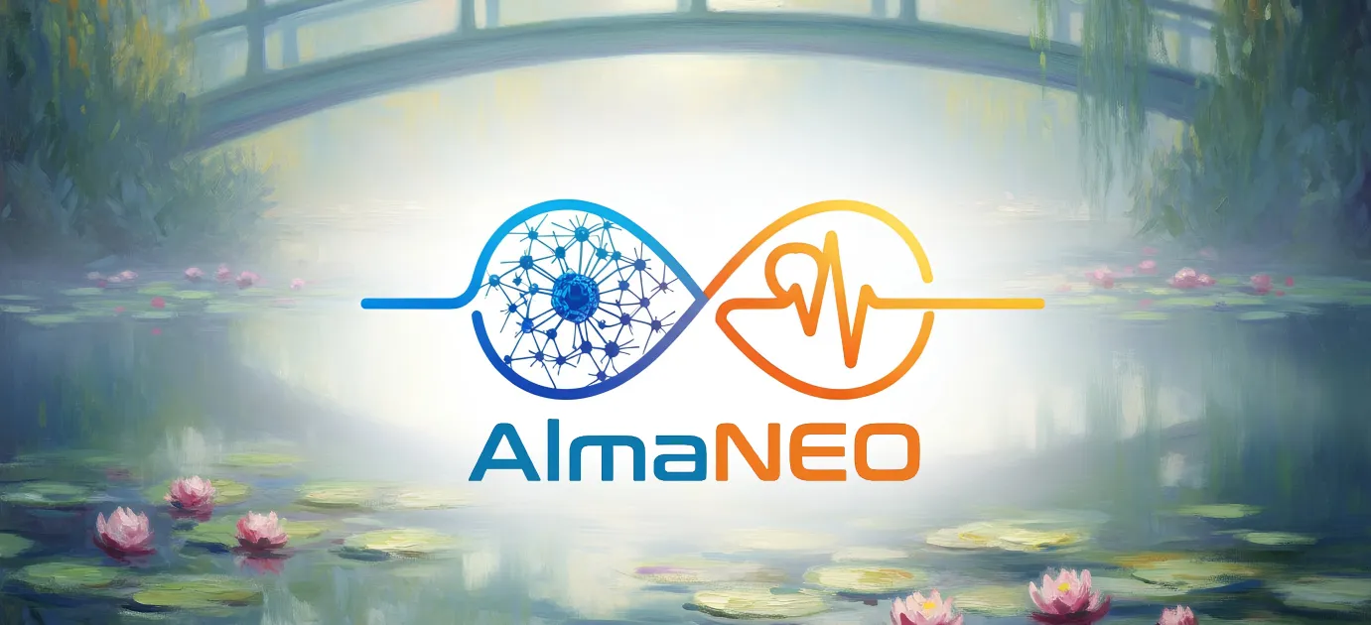

8 billion tokens for 8 billion people.

This is not a number, but a promise.

A promise to not lose our humanity even in the age of AI.

A promise to not turn away from the marginalized.

A promise to create a world where kindness is valued.

**AlmaNEO is the beginning of that promise.**

─────────────────────────────────────────────────────────────────

### Join Us

### AlmaNEO

**"Democratizing Intelligence, Cultivating Humanity"**

|  |
| --- |
| *Cold Code, Warm Soul.* |

|  |  |
| --- | --- |
| **Channel** | **Link** |
| Website | [https://almaneo.foundation] |
| Twitter | [Coming Soon] |
| Discord | [Coming Soon] |
| Email | [Coming Soon] |

─────────────────────────────────────────────────────────────────

**Thank you.**

*AlmaNEO Team*  
*January 2025, whitepaper V1. Written*  
*June 2025, whitepaper V2. Written*  
*January 2026, whitepaper V3. Written by*

─────────────────────────────────────────────────────────────────



*This document is White Paper v3.0, containing the vision and plans for the AlmaNEO project.*  
*The contents of this document may be updated as the project progresses.*